Lab6: Ensemble Kalman filter (EnKF)

In this lab, you are asked to perform data assimilation experiments using EnKF and Lorenz 3-dimensional model

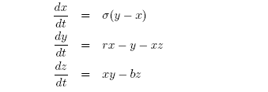

Set step size 0.01 and the time interval [0, 500]. Using the above initial
conditions to integrate Lorenz model, which produce the true values
$X_{\text{tr}}=[x_{\text{tr}},y_{\text{tr}},z_{\text{tr}}]$.

Assume the initial conditions have errors, estimate model states using EnKF. The observation data is obtained using true value perturbed by random number drawn from Gaussian distribution

Design some sensitivity experiments to explore EnKF performance

