Lorenz model is as below

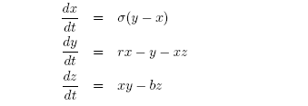

- Code Euler forward, Euler predictor-corrector, and central difference schemes; and use these schemes to solve Lorenz model with time step size 0.01 at the time interval [0, 500].

2) Code the 4th order Runge-Kutta method to solve the Lorenz model with the same
step size and time interval.

3) Use Matlab function ODE45 to verify your result from 2).

4) Compare your results from 1), against 2) or 3)

5) Keep other parameters unchanged, except r =24, repeat 3).

6) Vary the initial conditions to repeat 3) and 5) to see whether you can observe chaos.
Discuss what you observe.

