Chapter 5 Time Series Analysis

5.1 The linear trend Analysis

A linear trend analysis is often conducted to examine whether a particular data set (say, the global mean temperature) has increased or decreased over a period of time (i.e., the global warming). A trend line could simply be drawn by eye through a set of data points, but more properly their position and slope is calculated using statistical techniques like linear regression.

5.1.1 Visualization

A commonly used visualization method is to calculate the mean in a running-window, also called moving average. In statistics, a moving average (rolling average or running average) is a calculation to analyze data points by creating series of averages of different subsets of the full data set. It is also called a moving mean or rolling mean.

Given a series of numbers and a fixed subset size, the first element of the moving average is obtained by taking the average of the initial fixed subset of the number series. Then the subset is modified by "shifting forward"; that is, excluding the first number of the series and including the next number following the original subset in the series. This creates a new subset of numbers, which is averaged. This process is repeated over the entire data series. The plot line connecting all the (fixed) averages is the moving average. A moving average is a set of numbers, each of which is the average of the corresponding subset of a larger set of datum points. A moving average may also use unequal weights for each datum value in the subset to emphasize particular values in the subset.

For a time series $x_{i}$ (i=1,2,…,N) , the moving average $y_{k}$of a running-window of M+1 can be written as below
$y=\frac{1}{M+1}\sum_{j=k−M/2}^{j=k+M/2}{x_{k+j}}$ (1)

Or

$y=\frac{1}{M+1}\sum_{j=k}^{j=k+M}{x_{k+j}}$ (2)

The difference between (1) and (2) is to set where is the position of the moving average. In (1) the position of the moving average is set at the middle of the moving window; while in (2) it is set at the beginning of the running window. Both are fine depending on the preference of users. The new times series of the moving average has the sample size of N-M. For example, if M=4, the new data at point of 80 can be obtained using (1) and (2), respectively;

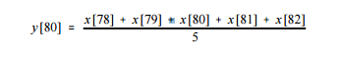

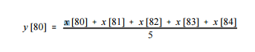
A moving average is commonly used with time series data to smooth out short-term fluctuations and highlight longer-term trends or cycles.

Below is the example of the moving average as shown in red line in the figure.

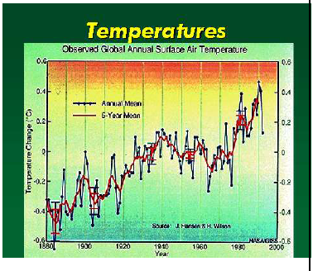

5.1.2 Linear Regression
A quantitative method to measure the linear trend is by linear regression. For a time series $x_{i}$ (i=1,2,…,N) ,
We can built a simple univariate regression using time step i as predictor, i.e.,

$y=a_{0}+a_{1}∗i$ (3)

Here $a_{0},a_{1}$are regression coefficients. The linear tend is measured by the slope of the regression, i.e., $a_{1}$. A significant positive value of $a_{1}$ indicates an increase of y with time step i, otherwise an decrease of y with i.
A statistical significant test should be performed for this purpose.

Below is an example to measure the linear trend by regression as shown in black line.

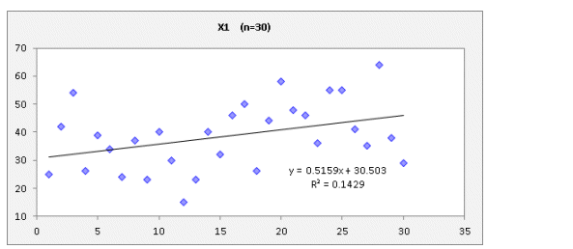

5.2 Spectrum and Period analysis

5.2.1 Fourier analysis

With time series data, an alternative way to view the data is via the frequency representation first developed by J. B. Fourier in the early nineteenth century. Given a function y(t) defined on the interval [0,T], the Fourier series representation for y(t) is

$\tilde{y}(t)=\frac{a_{0}}{2}+\sum_{m=1}^{∞}{[a_{m}\text{cos}(ω_{m}t)+b_{m}\text{sin}(ω_{m}t)],}$ (4)
With the (angular) frequency $ω_{m}$ given by

$ω_{m}=\frac{2πm}{T},$ m =1,2, … (5)
For a discrete time series, $y(t_{n})≡y_{n},$ n=1, …, N. With a sample interval $Δt,$ the samples are collected at time $t_{n}=nΔt$
$y_{n}=\frac{a_{0}}{2}+\sum_{m=1}^{M}{[a_{m}\text{cos}(ω_{m}t_{n})+b_{m}\text{sin}(ω_{m}t_{n})],}$ (6)
where M is the largest integer <=N/2 and N is the length of sample.

The Fourier coefficients are given by

$\begin{aligned}a_{0}=\frac{2}{N}\sum_{n=1}^{N}{y_{n}=2\overline{y}} \\ a_{m}=\frac{2}{N}\sum_{n=1}^{N}{y_{n}\text{cos}(ω_{m}t_{n})=}\frac{2}{N}\sum_{n=1}^{N}{y_{n}\text{cos}(\frac{2πm}{N}}nΔt) \\ b_{m}=\frac{2}{N}\sum_{n=1}^{N}{y_{n}}\text{sin}(ω_{m}t_{n})=\frac{2}{N}\sum_{n=1}^{N}{y_{n}}\text{sin}(\frac{2πm}{N}nΔt)\end{aligned}$ (7)

The cosine and sine functions have orthogonality properties:

$\begin{aligned}\sum_{n=1}^{N}{\text{cos}(ω_{l}}t_{n})\text{cos}(ω_{m}t_{n})=\frac{N}{2}δalignl{\begin{aligned}\text{lm},\end{aligned}}_{}\end{aligned}\sum{\text{sin}(ω_{l}t_{n})\text{sin}(ω_{m}t_{n})=\frac{N}{2}}δ_{\text{lm}},\sum{}\text{cos}(ω_{l}t_{n})\text{sin}(ω_{m}t_{n})=0$ (8)

where $δ_{\text{lm}}$is the Kronecker delta function (which equals when l=m, and 0, otherwise).

5.2.2 The discrete spectrum

The variance of the time series y can be written in terms of its Fourier coefficients

$\begin{aligned}\text{var}(y)=\frac{1}{N}\sum_{i=1}^{N}{(y_{n}−\overline{y_{n}})^{2}}=\frac{1}{N}\sum_{n}{(y_{n}−\frac{a_{0}}{2}})^{2} \\ \frac{1}{N}\sum_{n}{[\sum_{m}{(a_{m}\text{cos}(ω_{m}t_{n}}})+b_{m}\text{sin}(ω_{m}t_{n})]^{2}\end{aligned}$ (9)

Using (8), (9) can be expressed in terms of the Fourier coefficients

$\text{var}(y)=\frac{1}{2}\sum_{m}{(a_{m^{2}}}+b_{m^{2}})$ (10)

The autospectrum, also called the power spectrum, is defined as

$S_{m}=\frac{T}{4π}(a_{m^{2}}+b_{m^{2}})=\frac{NΔt}{4π}(a_{m^{2}}+b{}^{2})$ (11)

Since $\frac{NΔt}{4π}$ is a constant, the power spectrum is also defined as
$S_{m}=\frac{1}{2}(a_{m^{2}}+b_{m^{2}})$ (12)

Thus (10) can be expressed as

$\text{var}(y)=\sum{SΔω}$ (13)
with $Δω=\frac{2π}{T}=\frac{2π}{NΔt}$ (14)

Hence, the spectrum $S_{m}$can be viewed as the variance or ‘energy’ in the $ω_{m}$frequency band (with bandwidth $Δω$), and the total variance var(y) can be computed by integrating $S_{m}$over all frequency bands. When $S_{m}$is plotted as a function of the frequency, peaks in $S_{m}$reveal the frequencies where the energy is relatively high.

From (5), the lowest frequency in the spectrum, known as the fundamental
frequency, is

$ω_{1}=\frac{2π}{T},\text{ or f}=\frac{1}{T}$ (15)

Often a time series displays a trend, i.e., a positive or negative slope in the data over the time record. Fort instance, the Canadian prairie yield shows a positive trend with time, largely due to the gradual improvement in agricultural technology. The frequency associated with a trend is lower than the fundamental frequency, thus energy from the trend will leak to other low frequency spectral bands, thereby distorting the low frequency part of the spectrum. By subtracting the linear regression line from the data time series, trends can easily be removed prior to spectral analysis.
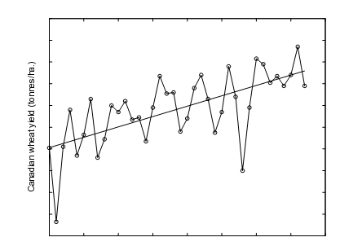

The highest resolvable frequency from (5) is $ω=2πM\text{ / }T$, but with $M≈N/2$, we have $M/T≈1/(2Δt)\text{.}$ Hence the highest resolvable frequency, called the Nyquist frequency, is

$ω_{N}=\frac{π}{ΔT},\text{ or }f_{N}=\frac{1}{2ΔT}$

To resolve a wave of period of period $τ$, we need at least two data points to cover the period $τ$, i.e. $τ=2Δt=\frac{1}{f_{N}}$. Aliasing arises when $Δt$ is too large to resolve the highest frequency oscillations in the data. Fig.3.2 illustrates a signal sampled too infrequently, resulting in an incorrect inference aliased signal of much low frequency.

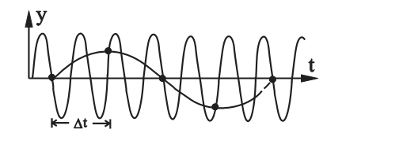

From (5), the frequency $Δω$ between adjacent frequency bands is

$Δω=\frac{2π}{T}$

The ability to resolve neighboring spectral peaks is controlled by $Δω$, which is proportional to 1/T. Hence a longer record T will yield sharper spectral peaks, thereby allowing the resolution of two signals with close-by frequencies as distinct peaks in the spectrum. A shorter record will blur the two signals into a single spectral peak.

The raw spectrum $S_{m}$ calculated from (11) is often very noisy in appearance. There are two common methods for smoothing the spectrum: (a) band-average (or running mean) is applied to the raw spectrum

${\tilde{S}}_{m}=\frac{1}{(2K+1)}\sum_{k=−K}^{K}{S_{m+k}}$

where ${\tilde{S}}_{m}$is the smoothed spectrum resulting from averaging the raw
spectrum over 2K+1 frequency bands.

In method (b), the data record is divided into J blocks of equal length L=T/J. Compute the spectrum for each block to get $S_{m^{(j)}}$ (j=1,…, J). The spectrum $S_{m}$is then the ensemble average over the J blocks:
$S_{m}=\frac{1}{J}\sum_{j=1}^{J}{S_{m^{(j)}}}$
Method (b) has an advantage over (a) when there are data gaps --- in (b), the data gaps do not pose a serious problem since the data record is to be chopped into J blocks anyway, whereas in (a), the data gaps may have to be filled with interpolated values or zeros. The disadvantage of (b) is that the lowest resolvable frequency is $f_{1}=1/L=J/T$, hence there is a loss of low frequency information when the record is chopped up.

There is a trade off between the variance of the spectrum S and the band width. Increasing the band width (by increasing K or J) leads to a less noisy S, but spectrum peaks are broadened, so that nearby spectral peaks may merge together, resulting in a loss of resolution.

    - Statistical test of spectrum

$F=\frac{\frac{1}{2}(a_{k^{2}}+b_{k}^{2})/2}{(\text{var}(y)−\frac{1}{2}a_{k}^{2}−\frac{1}{2}b_{k}^{2})/(n−2−1)}=\frac{S_{k}∗(n−3)}{\text{var}(y)−S_{k}}$ ~ F(2, n-3) (16)

The significant test is conducted using (16), i.e., a comparison is made between actual F value and the critical value from F-table. Typically the test is performed for relative maximum spectrum. The procedure is like

- Plot the spectrum from (12), as a function of k, wave number;
- Chose relative maximum value of $S_{k}$ , calculate F, and then do the test;
- If the test is statistically significant, the period corresponding to the k is $S_{k}$= 2*M/k; where t
the M is number used to perform Fourier analysis in (6).

  - Auto Regression Models -- (AR) model

Another simple time series model is the first order auto-regression , denoted by AR(1). The series $x_{t}$ is AR(1) if it satisfies the iterative equation

$x_{t}=a_{1}x_{t−1}+ε_{t}$ (17)

For a m-order AR model AR(m), we have

$x_{t}=a_{1}x_{t−1}+a_{2}x_{t−2}+\text{.}\text{.}\text{.}+a_{m}x_{t−m}+ε_{t}$ (18)

One can solve (17) and (18) in a framework of linear regression, which is discussed in Chapter 3. Alternatively we can also solve them using Yule-Walker method. For simplicity without losing generality, we
assume $x_{t}$ to be mean of zero, which can be achieved by animalization,

Multiple $x_{t_{−1}}$, $x_{t_{−2}}$, $x_{t_{−3}}$, …, $x_{t_{−m}}$on both sides of (18), and then take expectation on both sides, respectively, we have below equations:

$\begin{aligned}r_{1}=a_{1}r_{0}+a_{2}r_{1}+\text{.}\text{.}\text{.}+a_{m}r_{m−1} \\ r_{2}=a_{1}r_{1}+a_{2}r_{0}+\text{.}\text{.}\text{.}+a_{m}r_{m−2} \\ r_{3}=a_{1}r_{2}+a_{2}r_{1}+\text{.}\text{.}\text{.}+a_{m}r_{m−3} \\ \text{.}\text{.}\text{.}\text{.} \\ r_{m}=a_{1}r_{m−1}+a_{2}r_{m−2}+\text{.}\text{.}\text{.}+a_{m}r_{0}\end{aligned}$ (19)

Where $r_{k}=E(x_{i}x_{i−k})=\frac{1}{N−K}\sum_{i=k+1}^{N}{x_{i}x_{i−k}}$ (20)

Denote

$R=\begin{aligned}\left[r_{0},r_{1},\text{.}\text{.}\text{.}r_{m−1} | \right]\left[r_{1},r_{0},\text{.}\text{.},r_{m−2} | \right]\left[\text{.}\text{.}\text{.}\text{.} | \right] \\ \end{aligned}$ $C=\begin{aligned}\left[r_{1} | \right]\left[r_{2} | \right]\left[\text{.}\text{.}\text{.}\text{.} | \right] \\ \end{aligned}$ $A=\begin{aligned}\left[a_{1} | \right]\left[a_{2} | \right]\left[\text{.}\text{.}\text{.}\text{.} | \right] \\ \end{aligned}$

(19) can be written

$\text{RA}=C$, namely, $A=C/{R^{−1}}$ (21)

