
Marian Minar November 24, 2007

Aboriginal Education Philosophy Statement
Adapted from: “Keeping the Fire Strong” (Liard Goulet)

Introduction
Our memories and our stories of days gone by live inside our cultures, inside our bodies, and inside our minds. Days to come will be looked upon in relation to this past and inevitably, according to the philosophies we are all carrying. If a philosophy had a form, it would no doubt point to an immense collection of experiences and ideas that not only our own, but a complex accumulation of thoughts and “footprints” of others.
I would like to present my philosophy in three parts. In Part 1, I will outline my journey that has led me to this point, including my thoughts about what an educational philosophy statement should embody. Having had the exposure of many different Aboriginal philosophies, I will also try to articulate how my perspective has changed and how my world-view has changed as a result. In Part 2, a personal interpretation of the collection of Aboriginal philosophies I have analyzed will be given as well as a pictorial analogy of my philosophy in the same theme as I have experienced them. Finally, in Part 3, I will set out to explain the strategies, teaching tools, and goals (for the teacher and learner) I intend to implement in the framework of my philosophy.

Part 1

What I think an educational philosophy statement should embody
An educational institution such as a school, really a construct of culture (according to Jerome Bruner), is a shifting and changing creature whose form is both altered by its members, and reciprocally alters them with experiences, good and bad. Any educational philosophy will need to include the realization that school is both a form of culture and culture-making. Education is restricted by it, and yet it feeds culture all at once.
What are the immediate results of such a viewpoint? Educators of Aboriginal children must reflect upon the ways that they deliver and discuss knowledge, in sensitivity of the “how” and “when” and “why” of the culture they are conveying. Administrators will need to structure their schools so that the perspectives and authentic differences of non-dominant cultures are not silenced. It is a valuable tool to be able to think and feel in a different perspective, even if there are some aspects that cannot be conveyed. It teaches

“Red Cover” (Alex Janvier)
a valuable lesson about how cultures can still be coherent inside a close-knit learning community, how they can exists with little or no negative repercussions (prejudice being the main one).
An Aboriginal educational philosophy should guide educators with the wisdom and insight shared by Aboriginal peoples in their writings and stories. Certainly, the philosophy of a teacher who is given the task of teaching Aboriginal children in a classroom will need to present local knowledge and a local perspective. Ideally, the language of the classroom would reflect that of the student population (if at all possible).

How I have changed as a result of thinking about Aboriginal philosophies
I began to learn about Aboriginal history and culture in the first year of my program at UNBC, through an introductory course in the subject. At the time, we were given the task of composing lesson plans that would suit Aboriginal learners specifically by way of introducing indigenous knowledge with the specified learning outcomes of ministry. Also, we were to attain any planned learning outcome of the First Nations curriculum and connect these to the lesson plans to be taught. As a mathematics teacher, I found it difficult to think of a way to inscribe traditional knowledge and history into a particular lesson. I struggled with ideas but the final product was a few, reasonable lesson plans focusing on problems involving iconic indigenous knowledge: the medicine wheel, the teepee, the longhouse, etc.

(www.literacyjournal.ca)
Although these lesson plans frustrated me, it would certainly be less than that of my learners who would no doubt find my lessons to be more so. The narrative mode of thought, as described by Bruner in many of his books, is to him an equally important way of thinking as logical-scientific. He has been an active critic of the way both frames of mind, and especially recent trends in the logical-scientific mode of thought, have been given far too much emphasis. He argues that the one is never irreducible to the other, but both have of equal importance for the understanding of the human mind. I have never had a chance to implement those lessons and there is no plan to do so. The next round of lesson planning will come with a deeper recognition of the importance of storytelling towards meaning-making. As my lesson plans included no storytelling at all, just “barebones problem solving with a dash of Aboriginal flavour”, I am intending to incorporate not artifacts or material products of the culture, but instead the products of the ways of sharing knowledge and sharing meaning.
“Spirit of The North Wind”, (Roy Thomas)
One similar aspect of the Aboriginal philosophies was that most had a structure wherein there were four integral parts: some were concerned with physical “elements” and some were concerned with a social aspect in some form (such as family, friends). I both cases, the integral parts were connected to one another, illustrating the connectivity between these important parts. As such, this has given me thoughts and questions about how I should approach connecting the curriculum to the students’ lives.
A language is the structure which creates and is created by culture and so the importance of language and its relationship to culture is imperative.
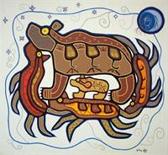
Willie Ermine encompasses the importance of language: “Our Aboriginal languages and culture contain the accumulated knowledge of our ancestors, and it is critical that we examine the inherent concepts in our lexicons to develop understandings of the self in relation to existence.” (Ermine, 1995, p. 104).
Speaking of language inevitably leads to the importance of storytelling and its influence on the individual and culture as a whole. In fact, the “importance of narrative for the cohesion of a culture is as great, very likely, as it is in structuring an individual life” (Bruner, 1996, p. 40). The role of storytelling in the classroom is one of a humanistic meaning-making nature, one that guides the learner into a stronger connection with the idea at hand. Unfortunately, according to Bruner, “[i]t has been the convention of most schools to treat the arts of narrative – song, drama, fiction, theater, whatever – as more ‘decorative’ than necessity, something with which to grace leisure, sometimes even as morally exemplary” (Bruner, 1996, p. 40).

How I will lay out my philosophy and connect it to the curriculum
The majority of the philosophies that we have covered have involved analogies of some kind. Whether they are pictorial or metaphorical, they lay out the world-view of a particular philosophy in terms of smaller pieces that comprise the structure of a larger perspective. This is what I intend to do: to give a visual representation of my philosophy that will enhance my view-point.
Following the analogy, I will explain and construct a philosophy which encompasses the philosophies I have been exposed to and to synthesize a view-point that will illustrate how I will teach and learn to an Aboriginal platform. The philosophy will encompass the importance of culture, self, and the relation between the two. Finally, I will add to that tools and goals, as well as differentiated instructional strategies that I will employ in order to complete the picture as a whole.

Part 2

Summation of Aboriginal Philosophies
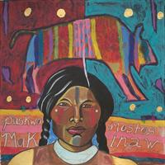
Just as the student is at the centre of many of the philosophies I have encountered (Cooper, 2000, p. 16), my philosophy will be no different: the students will be at the centre of their learning experiences. The student will have more responsibility within a guided framework in order to achieve success. Involvement and responsibility from the community and to the community is also a common theme from local sources, where service and culture are interrelated (Robinson, 2007).
Another common theme among the philosophies of Aboriginal education is holism. Holism is perhaps the opposite, anti-thesis to Cartesian reductionism: that is, instead of reducing a thing into its components, looking at a multitude of components that encompass a central idea which will yield an explanation of that idea. Willie Ermine in (Ermine, 1995) states that “The ‘fragmentary self-world view’ that permeates the Western world is detrimental to Aboriginal epistemology.” However, I do not think that it has to be this way. Authentic holism would most likely embrace the scientific mentality of the Western World and the uncertain, humanistic, narrative culture of the Aboriginal World. I do not think that both worlds lack either view-point (as I had recently presented to the class of Education 446). More likely, is that “no culture is without both of them, though different cultures privilege them differently” (Bruner, 1996, p. 40).
Elders are the critical link to Aboriginal epistemology through the Aboriginal languages (Littlebear, 2000). They are critical in that they are the link to the past before European colonization, they embody the language and culture that is needed to resuscitate the now-aging population of residential school survivors. Not only this, but they are most importantly the key to allowing for a better curriculum to emerge; a synthesis between the needs of two cultures.

A visual analogy of my philosophy
Culture
Logic-Mathematical Meaning-Making
Self
Narrative Meaning-Making
The Igloo Analogy

The visual analogy of my philosophy is that of an igloo. I chose to have four (4) main support directions to my igloo: a direction that represents culture, self, narrative, and logical-mathematic thinking. Each direction is important for the structure of the igloo; each represents the strength it gives to the entirety. The igloo is a home amidst the harsh environment of the outside; it supports and protects the occupants from the ever changing wind, temperature and the otherwise ever-changing environment. The strength of the whole will depend on the balanced support that each piece brings to the igloo.

Explanation of the philosophy
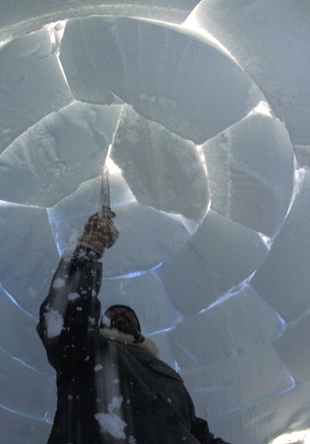
When one builds an igloo, he or she begins at the bottom, constructing the base of the igloo, and slowly working upwards toward the center. Each piece plays an important role in the creation of the structure that will house the inhabitants from the cruel forces of nature. Each block is cut in the right shape and is put into place at the right time. And so too the four pieces of the igloo (self, culture, narrative, logical) must be of the right shape and right size and be placed at the right time for the integrity of the igloo to be strong.
The narrative/logic-mathematical meaning-making arc is perpendicular to the culture/self arc as they cross and meet at the top. Both aspects the each arc are components of the complete structure in one direction; they complete exactly one-half of the igloo and support each other from opposing sides. As one works upward toward the center of the igloo, the four structures converge to one single block. This “key” block completes the igloo and it also lies inside the domain of each of the four themes, and provides the structural integrity to the igloo. It is this important block that gives balance, literally, to the ability of the igloo to withstand pressure from the outside, the ability to bring all of the pieces to one point.
“Adrew Taqtu Constructing an Igloo” (Paul Nicklen Photography)
I feel that this analogy demonstrates many of the things that I have already discussed. Firstly, it provides the importance on holism and that each part is necessary but not sufficient for a philosophy to remain intact. Community, interpersonality, storytelling, bonding, emotion, structure, and pure thought all emerge from the igloo analogy. These will all be a part of my philosophy for education, one that reserves a place for all learners, Aboriginal and non-Aboriginal.

Part 3

Goal for Aboriginal learners from my philosophy

The goals for Aboriginal learners within my philosophy are threefold:
- Aboriginal learners coming from a narrative perspective, who have strong ties to their community, will attain a stronger sense of self and individual history through storytelling and gain respect for other learners (Hampton, 1995, p. 31)
- To be able to use logic-mathematical meaning-making to influence the narrative ways of knowing about the world and for narrative meaning-making to influence the logic-mathematical ways of knowing the world
- To have a foundation of tools and meanings that will contextualize their lives, so that each learner can find his or her way in a physical, emotional, and spiritual world; so that no talent or story of any one learner goes unseen or unheard.

Goal for Teaching from my philosophy
I also have three goals for myself as a teacher of Aboriginal youth:
- To familiarize myself with the various background of each student through storytelling so that I may better reach their prior knowledge and experiences with the knowledge at hand
- To integrate narrative ways of knowing into logic-mathematical ways of knowing and vice-versa in order to differentiate the ways of lesson delivery and so that each Aboriginal student is afforded opportunities to learn the material from different perspectives.
- To develop an understanding and rapport with my students, so that I have many ways of reaching them, be it through constructive, contextual storytelling or through rigorous, clear-minded analysis, but having a strong relationship with my students.

A strategy: storytelling across the curriculum
Storytelling has always captivated and motivated students throughout the ages. As a teaching tool it has always had a special place in the heart of Aboriginal learners. Some of the ways storytelling is beneficial in a classroom are listed below (thank you to the class of Educ 446 for most of these ideas).
- Stories can create powerful and meaningful analogies and add to the strength of analytical thought
- Bringing in outside sources, such as newspaper articles that are relevant to the subject
- Personal experiences add to the analogies
- Linking the subject or topic to the students’ lives to make it more relevant
- Stories show universality of experiences in humanities
- Helps kids connect historical events and political themes to their own lives
- Helps to teach empathy and creates connections between all students
- Strengthens understanding by providing analogy/metaphor/framework for new knowledge
- Sequence of events = better recall
How these benefits are arrived at:
- Through anecdotes
- Oral interviews, oral/written response
- Personalize/internalize/identify (engage the students with stories)
- Scaffolding previous information
- During teachable moments, pause lesson and tell a story
- Current events
- Begin a lesson by telling a story

Conclusion
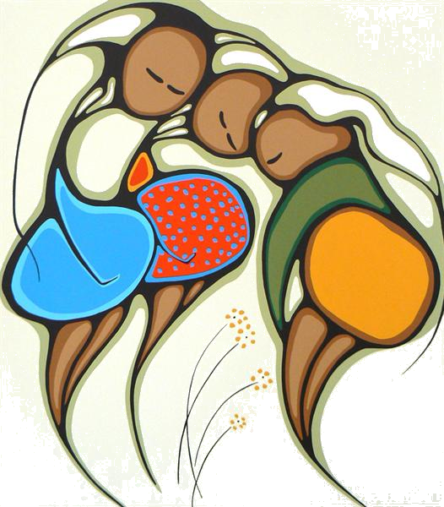
"Treat the earth well: it was not given to you by your parents, it was loaned to you by your children. We do not inherit the Earth from our Ancestors, we borrow it from our Children."
(Ancient Ameri-Indian Proverb)
As educators, we travel from a place where we borrow if not the land, then the air, spirit, and joy that our children have lent us. We must treat their well-being with utmost care, their needs and their backgrounds must forever be a part of the culture that we create as a group inside the educational community.
My philosophy, written and drawn, will serve as a guide for future practices. The thoughts and feelings that have materialized from the knowledge of stories, of literature, of my immediate environment are of my own creation. Yet, I owe this knowledge and understanding to my closest love, my family, and my friends.
With my Aboriginal students, I will discover their strengths and weaknesses; their histories and backgrounds; storytelling will pave the way for new understandings regardless of content or topic.
“Spring” (Daphne Odjig)

Works Cited
Bruner, J. (1996). The Culture of Education. Cambridge, Massachusetts: Harvard University Press.
Cooper, M. K.-B. (2000). Gathering TOgether to Travel to the Source: A Vision for a Language and Culture-Based Educational Model. In J. E. Cooper, Indigenous Education Models for Contemporary Practice (p. 16). Mahwah, N.J.: Lawrence Erlbaum Associates.
Ermine, W. (1995). Aboriginal Epistemology. In M. B. (Eds.), First Nations education in Canada: The Circle Unfolds (pp. 101-112). Vancouver, B.C.: University of British Columbia Press.
Hampton, E. (1995). Redefinition of Indian Education. In M. B. (Eds.), First Nations education in Canada: The Circle Unfolds (pp. 5-46). Vancouver, B.C.: UBC Press.
Littlebear, L. (2000). Jagged Worldviews Colliding. In M. Battiste, Reclaiming Indigenous Voice and Vision (pp. 77-85). Vancouver, B.C.: UBC Press.
Robinson, R. (2007). Education Transformation: Issues for Implementing an Aboriginal Choice School in Prince George, B.C. UNBC , 185.

