Section One

Section Two
Question1
There are thousand of stocks in the market, and we put all the stock into a portfolio. We can lend or borrow money at risk free rate. If we can borrow money at risk free rate, we can extend the possibilities beyond S. The line gives us a higher expected return for any level of the risk than just invest in common stocks.
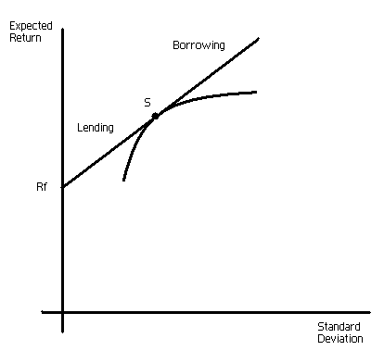
Question 2
To use industry beta can cancel out when estimate betas of portfolio. However if we are lack of information about the company, industry beta

Question 3
False.
Diversification is a dubious reason for mergers. Although diversification is easier and cheaper for stockholders, Investor should not pay a premium for diversification since they can do it themselves. Corporate diversification does not increase value in perfect markets as long as investor’s diversification opportunities are unrestricted.

Question 4
False.
Reasonable Borrowing does not significantly affect the probability of financial distress or bankruptcy. PV (cost of financial distress) is small and tax advantages dominate. Moderate borrowing will increase cost of equity.

