Assignment 1: Enron Corporation

Jacky Mak
230066081

Commerce 310: Intermediate Accounting
Han Donker
University of Northern British Columbia
January 19, 2007
Enron Corporation was a legend in America financial history, the stock price climbed up to $90, and the area of Enron business was Energy Service, Broadband Services, Transportation Services and Wholesales Services. Enron named “America’s Most Innovative Company” for six consecutive years since their companies and financial showed the company’s growth was strong. The revenue of Enron was $101 billion in year 2000, employed approximately over twenty thousands. Most of the investors thought Enron was a shining star and a leading company in Energy Industry. However, the star did not shine anymore, Enron collapsed with filed bankruptcy in late 2001. The material that made the shining star looked shining were not of the return on Enron’s investments, that was all about how hard the top executives played on the accounting books to hide the debt and played with financial derivatives. The chief executive officer Kenneth Lay, Jeffery Skilling and the chief financial officer Andrew Fastow was the creator of all the cheating methods in Enron, it made the top executives to put the money in their pocket safely. It became the most famous financial scandal history in America, it also be called “Enron scandal”. The accounting firm Arthur Andersen got involve in Enron scandal.
Kenneth Lay, the chief executive officer in Enron, signed Jeffery Skilling. Jeffery Skilling always comes up with new ideas with Enron’s business that how to maximize the profit of the company. Jeffery Skilling’s idea was to create a whole new world to delivery energy. He transformed energy to a financial instrument that can trade in the market. Jeffery Skilling suggested mark-to-market accounting method to Arthur Andersen, and Arthur Andersen agreed with mark-to-market accounting and signed it off, and U.S Securities and Exchange Commission approved it. Mark-to-market accounting allowed Enron to show the profits of their investment, all numbers based on Enron’s estimation which no one could prove.
The key of Enron successes was the technology boom of the stock market. Enron’s stock prices kept going up, plus the mark-to-market accounting. Kenneth Lay announced there was a 30 percent profit quarterly and the company would expect the stock price will go up by 50 percent next year, it made Enron’s stock price went up rapidly in year 1999 (Exhibit 1). Top executives knew there was opportunity to make a guarantee profit to cash into their pocket, which is called “pump and dump”. Top executives would buy a call option for Enron stocks. The call option had to pay a premium, but which allows those top executives to buy a stock at a certain price with an expiry date. After they purchased the option, those top executives would do whatever they could to pump up the stock price, it could make the call option able to exercise before the option expired, once they exercise the call option, they would sell it to the market immediately.
While the top executives enjoyed the share price go up rapidly, they also worried about the stock price would decline one day, they started to think of some new investments and new projects, the power plant in India, selling the bandwidth to other company. The truth was, all the projects and technology failed or did not fully developed, Jeffery Skilling tried to create illusion to show the investors and analysts that these projects will make profit in the future, by using mark-to-market accounting. Since the technology boom, Enron could mark up their projects on accounting book. It could make the company’s financial looked healthy and successful on those projects even it was losing money, moreover, the chief financial officer Andrew Fastow created a way to make Enron’s bad debt disappear. He performed this tricks by setting up over a hundred new companies, one of the company is called “LJM Investment”. Enron’s board waived the conflict of interest, they allowed Andrew Fastow to create company to run private partnerships with Enron. “LJM Investment” could help Andrew Fastow to purchase Enron’s bad debt, and Enron could turn those bad debts immediately into cash. Andrew Fastow repackaged the bad debt and turned it into financial products, and sold it to private investment bankers (Exhibit 2). Andrew Fastow putted Enron into a riskier position. He gambled Enron chose not to default on the fantasy projects and the stock price keeps going up. For example, the trick is similar to the cause of U.S. financial crisis happening now, the investment bankers bid on the housing market in U.S. and transformed those debts into different financial products. Those products usually were asset backed, as long as the housing market keeps going up, those people choose not to default, and all the investors will be fine.
If Enron’s projects were all in debt, it would be a question where the money came from in quarterly report. For those traders who worked for Enron revealed the secret, all the money came from the energy in California. Enron saw there is an arbitrage opportunity in California energy market, which is shut down the power plant to create rolling black out in California. Since the electricity was not able to supply the whole California, the price of electricity went to sky high. The retailer or the business in California had to pay for the expensive electricity bill, and the residences in California were suffered to pay for the electricity. In Enron’s trader’s position, they wanted to keep their job and maximize the profit of the company. The working environments of Enron’s traders were competitive, the concept of ethics was all covered by the profits or money, but all the money that the traders earned for Enron, and the money all went into Enron’s top executive’s pocket.
Even though Enron tried their best to make profits on those unethical strategies, they could not cover their loss on their imaginary projects. Jeffery Skilling knew Enron would collapse any day when the technology boom was over. Before this tragedy happened, Jeffery Skilling decided to sell all his Enron’s stocks and resign his job. Kenneth Lay and Andrew Fastow gave Enron’s employer confidence to buy the stocks by told them the company’s was doing fine and looked forward for the future growth, so they could sell their stock as fast as possible before Enron collapsed. The employee lost their jobs and lifetime savings. However, they only could walk away with the money but not the fraud and the evidences. The government took action of Sarbanes-Oxley Act (SOX) to respond Enron Scandal after, the act itself is costly but it played an important role to bring back investor’s confidence and more corporate and accounting control, plus it could prevent those financial scandals happens again.
Enron scandal showed us the dark side of the smartest people who played the financial game in Wall Street. The smartest people in Enron could make over billions of profit for themselves, but not for the company. They leveraged with company’s assets, made the wrong decisions on the projects and brought up too much fantasy for the company by creating offshore companies, units which to used to avoid taxes and raising the profitability. For those offshore companies, it helped Enron to hide the losses and made it looked more profitable than it actually was. All the smartest people could cash in from Enron before collapse, but the consequence was, they needed to spend some of their lifetime in jail. Arthur Andersen, was the largest accounting firm, faced the lawsuit of shredded documents related to auditing of Enron and suspended license for five years, 85,000 employee lost their jobs, and their reputation destroy immediately.
Exhibit 1
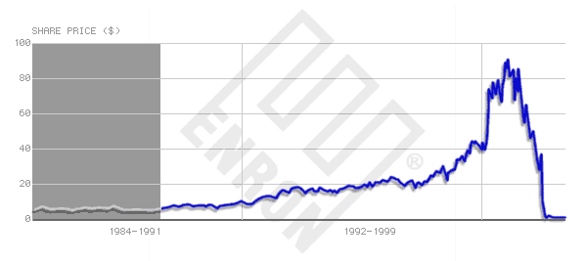
Exhibit 2
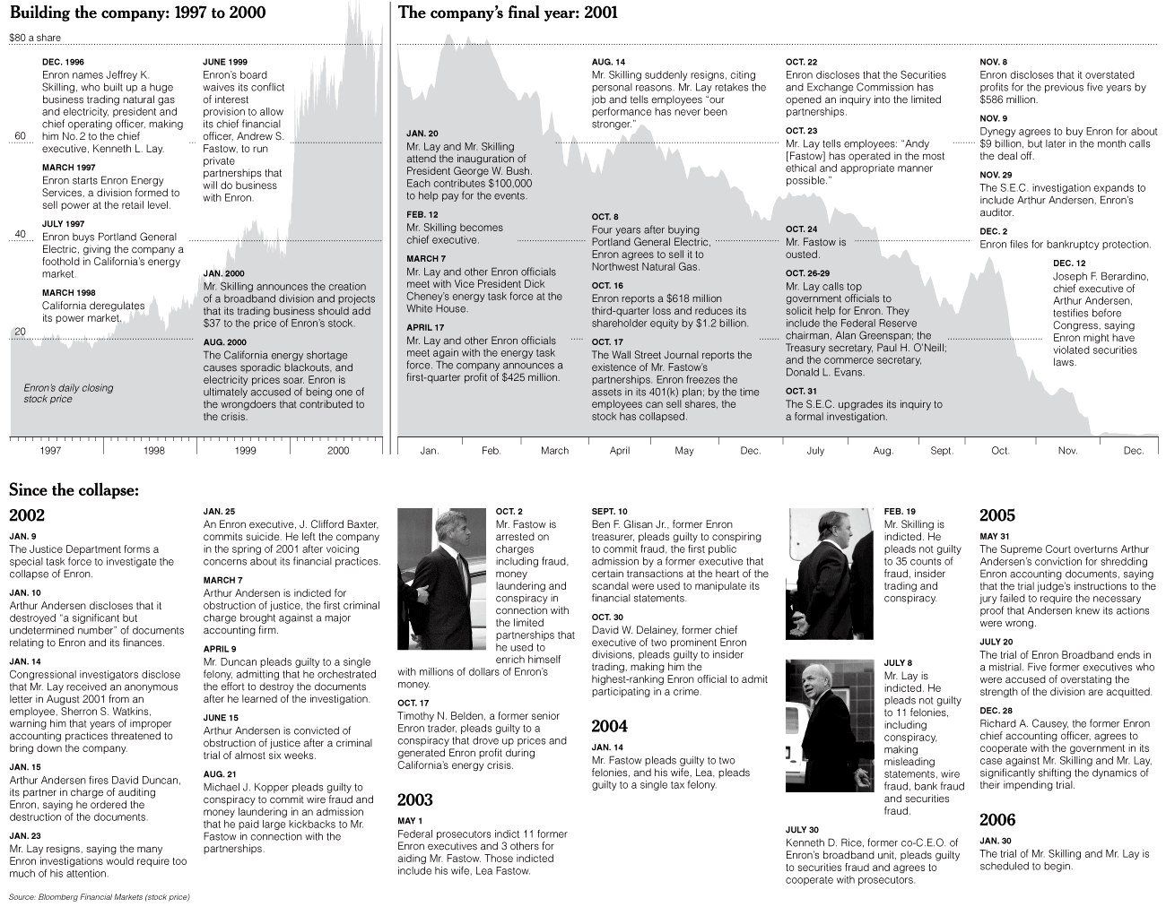
References
http://en.wikipedia.org/wiki/Enron#California.27s_deregulation_and_subsequent_energy_crisis
http://news.bbc.co.uk/hi/english/static/in_depth/business/2002/enron/timeline/2.stm
http://www.pbs.org/independentlens/enron/timeline2000.html
http://news.bbc.co.uk/2/hi/business/1780075.stm
http://en.wikipedia.org/wiki/Mark-to-market
http://www.fool.com/investing/dividends-income/2008/10/02/mark-to-market-accounting-what-you-should-know.aspx
http://en.wikipedia.org/wiki/California_electricity_crisis
http://www.democracynow.org/2006/5/26/enron_played_central_role_in_california

Enron: The Smartest Guys in the Room (2005)

