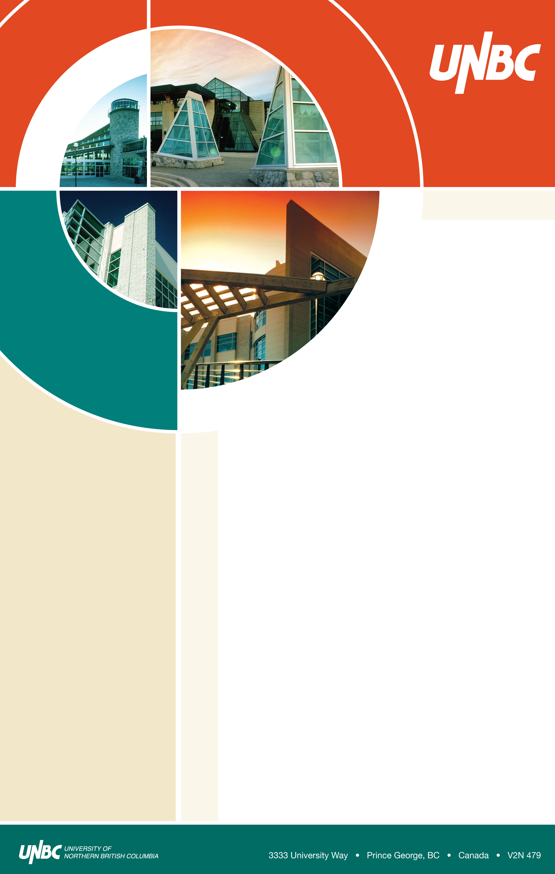
As a member institute,
we invite Faculty, Staff,
Students and the Public
to the celebration of

“40th Anniversary of
Shastri Indo-Canadian
Bi-national Institute”

Dec. 13, 2008
1:00-5:30pm
6-213 (Canfor Theatre)

1:00pm. Inauguration – Dr. Charles Jago, President, UNBC
1:05pm. Lecture Presentations
(Coordinated by Dr. Balbinder Deo)

- Legacy of Sri. Lal Bahadur Shastri – Sri. Bal Sethi (Speaker intro – Prof. Pranesh Kumar)
- Student Success and International Operation – Ms. Carolyn Russell
- Shastri Indo-Canadian Institute – Mission and Opportunities for Canadian Scholars and Students – Dr. Alex Aravind
- Economic Opportunities through International Research Collaboration between Canada and India – Dr. Ajit Dayanandan (Speaker Intro – Dr. Umesh Parshotam)
- Back from Death: Young Adults in Northern India Who As Children Were Said to Remember a Previous Life, With or Without a Shift in Religion – Prof. Antonia Mills, Shastri Grant Recipient (Speaker Intro. Dr. Mahi Aravind)

2:30pm. Cultural Program – Indian Dances
(Coordinated by Ms. Baldeep)
3:20pm. Concluding Remarks - Dr. Balbinder Deo
3:30pm. Break – Refreshments
3:45pm. Movie Screening - Bride and Prejudice

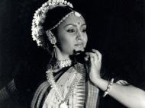

Organizing Committee
- Alex Aravind, Computer Science Program
- Balbinder Deo, Business Program
- Carolyn Russell, Director, Student Success and International Operation
- Baldeep, Computer Science

Light refreshments served

Monday, February 12, 2007
10:00 am to 11:00 am
Room 7-152 (Agora)

