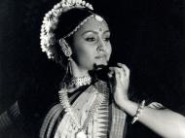

University of
Northern British Columbia

3333 University Way
Prince George, British Columbia
Canada V2N 4Z9

www.unbc.ca

Shastri Indo-Canadian Bi-national Institute
40th Anniversary


UNIVERSITY OF
NORTHERN BRITISH COLUMBIA
Cultural Programs

Item 1 - Song: Punjabi (Wanga)

Performers: Jasmine Dhillon, Tyra Parmar, Rupali Cheema, Shane Sandhu,
Jaya Jawanda, Taryn Jawanda.

Item 2 - Song: Punjabi

Performers: Shamita Aravind, Neelam Chatha, Justine Powar, Sooraj Banger, Benjamin Henderson.

Item 3, Song: Punjabi remix/ Hindi(oh ray piya)

Performers: Barkha Banger, Maviya Nijjer.

Item 4 - Song: Punjabi (Nagara-Nagara)

Performers: Satina Rai, Anika Rai, Simran Powar, Cevina Ghuman, Alysha Gill, Sonia Kandola.

Item 5 - Song: Hindi Song

Performers: Barkha Banger, Maviya Nijjer.

Item 6 - Song:Hindi Song

Performers: Satina Rai, Anika Rai, Simran Powar, Cevina Ghuman, Alysha Gill, Sonia Kandola.

“40th Anniversary of Shastri Indo-Canadian Bi-national Institute”
Dec. 13, 2008 [1:00pm - 5:30pm]

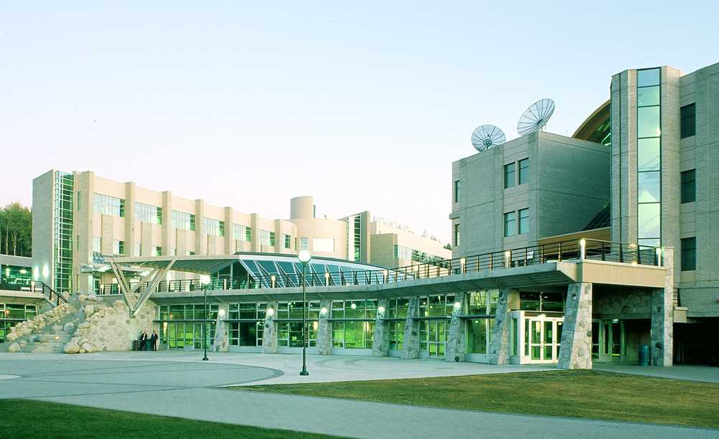
Programs

1:00pm. Inauguration – Dr. Charles Jago, President, UNBC
1:05pm. Lecture Presentations (Coordinated by Dr. Balbinder Deo)

- Legacy of Sri. Lal Bahadur Shastri – Sri. Bal Sethi (Speaker intro – Prof. Pranesh Kumar)
- Student Success and International Operation – Ms. Carolyn Russell
- Shastri Indo-Canadian Institute – Mission and Opportunities for Canadian Scholars and Students – Dr. Alex Aravind
- Economic Opportunities through International Research Collaboration between Canada and India – Dr. Ajit Dayanandan (Speaker Intro – Dr. Umesh Parshotam)
- Back from Death: Young Adults in Northern India Who As Children Were Said to Remember a Previous Life, With or Without a Shift in Religion – Prof. Antonia Mills, Shastri Grant Recipient (Speaker Intro. Dr. Mahi Aravind)

2:30pm. Cultural Program – Indian Dances
(Coordinated by Ms. Baldeep)
3:20pm. Concluding Remarks - Dr. Balbinder Deo
3:30pm. Break – Refreshments
3:45pm. Movie Screening - Bride and Prejudice

