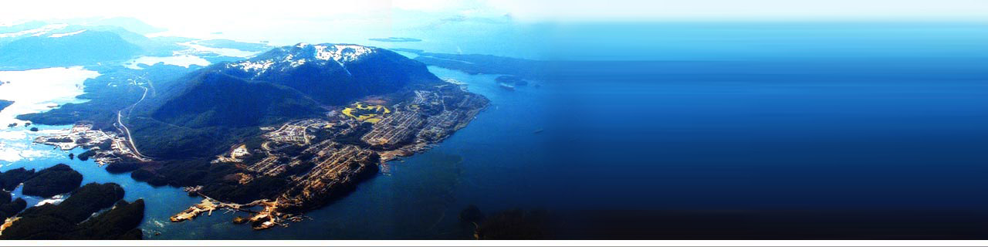

Instructor: Jing Chen

Group Members:
Xu Wang
Yongyu Wei

Dec. 2nd, 2007

Prince Rupert Port
Introduction
Prince Rupert Port is a strategical port which is recently expanded and developed to meet the goal of exploring a new and efficient route between Asia and North America, and saving more on transportation of goods in the future as demand of international trading and shipping are increasing.
The Asian marketing has been dramatically raising in the past two decades base on its advantages of plenty of natural resources, abundant relatively cheaper labour, and more and more available capital which partly is the result of less and less restriction of foreign investments in many Asian countries. Because of the low cost of production which due to these factors, Asia is turning into the manufacturing heart of the world step by step. Today, Asia not only has spread its share to any other continents, but also spreads as large and quick as possible with its fast-growing production capacity. North America is one of beneficiaries that would rank Asia as the most important trader since the demand of lower-cost goods is so high here. Serving as connecters of Asia and North America, west-coast ports’ duty have been over weight for years; a well developed new port is needed urgently at this moment, and Prince Rupert Port, for this reason, is the best choice on the west coast.
Potential of Prince Rupert Port
Locates in Prince Rupert, northern BC, Prince Rupert Port is the strategical portal of North West Transportation Corridor. Fully equipped with modern, uncongested and complete facilities, the port is designed to be a multi-use container terminal which takes advantage of unprimitive road and CN rail network to distribute products to most of North America efficiently. Different from other west-coast ports such as Port Vancouver and Port of Los Angeles, Prince Rupert Port is sitting on the edge of a non-fully-urbanized harbour. When Prince Rupert was found as the terminus of Grand Trunk Pacific Railway (GTPR) on west side, waterfront was saved to develop ports. So Prince Rupert Port has plenty of reserved land for development and the relatively slower-growing urban area of Prince Rupert makes it possible and much easier to further expand the port. Moreover, like a backbone of Canada, the GTPR not only passes through every province between Prince Rupert and Winnipeg, but also connects with the Grand Trunk Railway in eastern Canada so part of cost could be saved by transporting products directly to the east. Therefore, Prince Rupert Port is predestined to be an important role of the connection between Asia and North America with all these approaching facilities.
History of Prince Rupert Port
Although Port of Prince Rupert is more twinkling today, its history is not fade at all. After the port was initially built in 1914, it was upgraded by Charles Melville Hays who was president of Grand Trunk Railway (GTP). But in 1919, financial crisis led GTP fell into bankruptcy; then it became state-owned and was merged by Canadian National Railways. In World War II, the port was expanded as a supporting station of Canadian and American military operation in the events of Pacific Theatre. In 1975, Prince Rupert Port was granted as “National Harbour” and some more often-heard facilities, like Fairview Terminal, were started to be built. Until 20 years later, the plan of constructing an international container terminal as the most efficient inbound port of ships that from Asia was announced to be executed soon. (Wikipedia)
Advantages of Prince Rupert Port
The plan of expanding Prince Rupert Port was not an accident not only due to the reason of the closer relationship between Asia and North America, but also because Prince Rupert has efficient rail routes and the harbour has its own prominent advantages. First, in terms of nautical miles, Prince Rupert Port is the closest port to Asia on the North America west coast. As we can see in the nautical miles table below, the smallest number in every column always 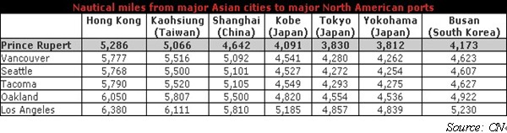is the top one which represents the distance between Prince Rupert Port and every main port in Asia. Correspondingly, time of sails also is much shorter for the Prince Rupert Port as showed in the table below. So, compare to other west-coast ports, location of Prince Rupert 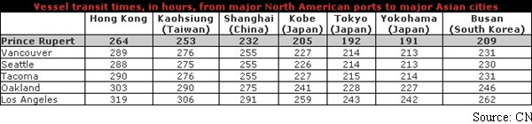Port is advantaged. Besides, the port also is cost saving in handling containers. To handle one twenty-foot equivalent unit (TEU) will only cost $340 in Fairview 1 and $250 in Fairview 2 which are the two containers terminals of Prince Rupert Port, but for the other terminals of Port of Vancouver, cost is much higher especially for the Vanterm, the cost is almost triple of that of Fairview 2. Therefore, as the distances are shorter, less time will needed for each trip, ocean carriers can return around faster. Then cost of both trips and containers is lower, so shippers can save a lot on transportation while the transportation is more efficient.
After containers arrive in the port, how to distribute products efficiently is another main issue needed to be concerned. Prince Rupert was set as the railhead of the CN rail so the low-cost rail facility is accessible. Like it was mentioned above, CN rail owns the largest rail network of Canada. With the 17,821-mile-long railway, it extends over the whole North America and plays a very important role in transporting inbound products since it is the unique railway which passes through ports of the Atlantic, the Pacific and the Gulf Coast. Meanwhile, the “network runs through the lowest-grade mountain passes in the Rocky Mountains, meaning less winter weather impact than other railways.” (Prince Rupert Port Authority) With less disadvantageous natural impacts in winter, transportation could be more efficient, and time and cost saving.
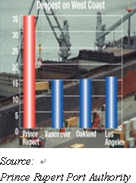
Besides all external advantages, the favoured conditions of Prince Rupert Port itself also push it inevitably to be the star of west coast. Ranging from 38 to 44 meters, the harbour of Prince Rupert is deepest among all ports on the west coast, and the depth is capable to handle 250,000 dwt and 8,000 TEU containerships. It also was ranked as one of safest port based on some main sailing factors like wind, channel width, and depth, and by the reason of proximity to open sea, the harbour is straight ice free in the year since the temperature is around 0°C. So, the Prince Rupert Port could be highly utilized around the year.
Tourism
Furthermore, other than the Fairview Terminals which has throughput capacity of 500,000 TEUs annually, Northland Cruise Terminal and Altin Cruise Terminal also are facilities of Prince Rupert Port and in service right now, and they have brought Prince Rupert pleasant incomes. Prince Rupert is a center point of Pacific coast from Vancouver to Alaska. During the summer time, the city visited by many cruise ships that travel via Vancouver and Alaska. But “in the year 2000, annual cruise activity in Prince Rupert was less than 10 vessels. From 2000-2002, the number of cruise ship arose from 15 to 25.” The situation dramatically changed in 2003 and 2004 that the Prince Rupert Port boomed and the new cruise ship terminal completed. “In 2004, the number of cruise ship was 35，55 in 2005 and over 70 in 2006. In 2007, the city expects to see 30% to 35% increase in marine. Till 2011, during the Alaska cruise season, the Prince Rupert will receive 120 passenger vessels with over 125,000 passengers arriving.” (Quality of Life Discussion Paper - City of Prince Rupert) The city of Prince Rupert also provides year-round ferries service from Prince Rupert to the Queen Charlotte Island and Vancouver Island for passengers. If people would like to go to Alaska, Alaska Marine Highway System regular offers ferries for them in Prince Rupert and take them to Ketchikan, the most populous city in the United State of Alaska. With more and more passengers will arrive in the city of Prince Rupert, local retailers, restaurants, hotels and shopping centers can spin-off more opportunities.
Besides the impact from cruise terminals, the railway also improves tourism of Prince Rupert. Prince Rupert owns a superior and no congestion rail connection to North American, so rail is another important transportation for the city. CN Rail uses for delivering the goods especially coal and grain and passenger service is operated by VIA Rail. “VIA operates trains in all regions of Canada over network spanning the country from the Atlantic to the Pacific, and from the Great Lakes to Hudson Bay.”(City of Prince Rupert) One of the classmates asked that is the backhaul containers are empty and who pay for the fees. The answer is the customers pay the headhaul and backhaul fees and most of the backhaul containers are empty. But why can’t the backhaul containers full? If can, I think that will be a good opportunity for Prince Rupert. Asian especially China is a major export and import country, “it can offer the potential for new industries for Prince Rupert, which can benefit the local economy (land based and jobs), as well as rail and port operations.” (Quality of Life Discussion Paper - City of Prince Rupert)
Because city of Prince Rupert is an ice-free harbor city and being known as the Halibut Capital of the World, more people go there for fishing. “Also the city is heavily supported by the commercial fishery and seafood processing industries.” (Tourism Website Builder)Thus, tourism is becoming more important to Prince Rupert’s Economy.
Employment & Housing
“Currently over 1.2 billion dollars of investment is planned in Prince Rupert by the year 2011.” (Port Business Opportunities Study) The major investment is construction of Fairview I and Fairview II which are represented as Phase I and Phase II. Phase I, which accomplished in October 2007, has throughput capacity of 500,000 TEUs (Twenty Foot Equivalent Units) and 58 acre site per year. Each larger container vessel has a 400-meter container ship quay. The extension of the wharf allows for water depth of 55 ft and container capacity of 7,000 TEUs. For refrigerator container stacks, Prince Rupert Port provides 144 plugs, with option for additional 72. The CN Rail supported to expand the rail yard enough to hold 17,000 ft of rail. Terminal and CBSA provided 3 to 4 Super Post Panamax cranes to handle the world’s largest container vessels to help Prince Rupert build a unique design to efficiently handle the rail business. Based on Phase I, Phase II continue expanding the port to 165 acres. This Phase will finish in 2010 and to accommodate an annual capacity of 2 million TEUs. The project expand quay to 1,400 meter, container yard capacity increase to 25,000 TEUs, 200 more refrigerator plugs will be used and 8 to 12 Super Post Panamax cranes will provide. Also 2 additional berths will be built and the dockside rail tacks will be to 30,000 ft.
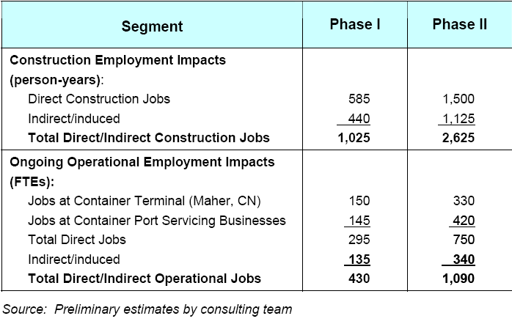
Other investment projects include Gaming/ Commercial development, Safeway, Starbucks, Power/ Wind Farm, LNG and Ridley terminals expansion.” (Port Business Opportunities Study & Prince Rupert Port Authority The New World Port) So, many projects will attract more workers come to Prince Rupert.
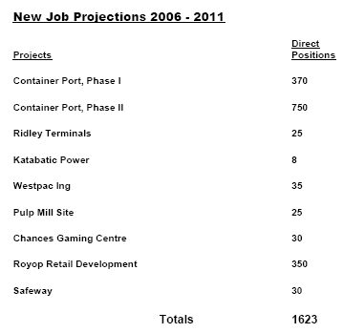(Source: BC Stats report)
“Till 2011, 1623 new direct jobs will be created in Prince Rupert and 560 jobs will be filled locally.” (Prince Rupert Job Projections) Indirect/ induced jobs and direct jobs are relevant to each other. “Direct jobs mean people directly interviewing of each project. Indirect jobs are additional employment in the community and induced jobs are jobs created by the spending of wages created from direct jobs.” These jobs can use mathematic method to calculate.
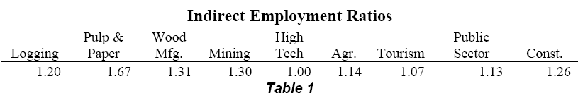
(Source: BC Stats report)
“The indirect job ration formula is (Direct Employment + Indirect Employment)/ Direct Employment.” (Garry Horne) So, there are 1623 direct jobs were created in Prince Rupert, the logging industry will need to employ additional 325 (1,623x0.2=324.6) workers since the t ratio is 1.20 (we can see it from the above table).
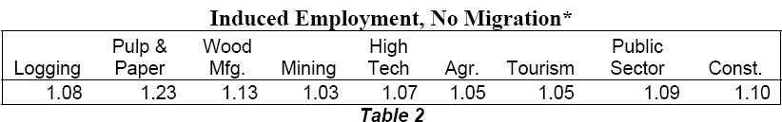
(Source: BC Stats report)
For instant, suppose there are 560 jobs will be filled in Prince Rupert; then the induced employment is 45 (560×0.08=44.8) (no migration) is easy to calculate.
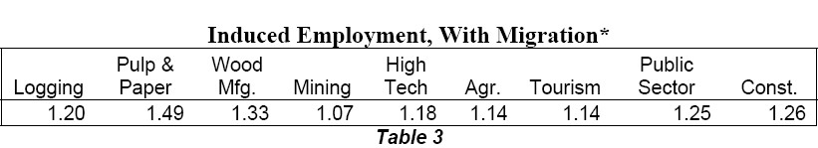
(Source: BC Stats report)
And the induced employment with migration is 257 (1623-560=1063 which is the number of employees that are from out of the community, 1063×0.2=212, 212+45= 257) As we can see that during next five to twenty years, labor force and population will growth, which directly impact on the housing demand. So in the future, the housing prince in Prince Rupert will be increase especially the house with water views.
Conclusion:
With its unique geographical location, Prince Rupert enjoys a nature-endowed advantage in its natural harbour and fully develops the port as a new world port to create shorter routes and relationships with Asia. Tourism, port expansion and other investment projects all have brought about a prosperous economy to Prince Rupert, and the city and going to grow unceasingly, therefore Prince Rupert is a potential city for investment.

Work Cited
Prince Rupert Port Authority. Wikipedia. 10 Nov. 2007 <http://en.wikipedia.org/wiki/Port_of_Prince_Rupert>
Ports and Docks. CN. 8 Nov. 2007 <http://www.cn.ca/specialized/ports_docks/prince_rupert/transit/en_KFPortsPrinceRuper t_transit.shtml>
Strategic Advantages. Prince Rupert Port Authority. 8 Nov. 2007
<http://www.rupertport.com/advantages.htm>
City of Prince Rupert. 21, Nov, 2007
<http://www.princerupert.ca/page.php?id_page=121&id_section=3>
Garry Horne, “British Columbia’s heartland at the dawn of the 21st century; 2001 economic dependencies and impact rations for 63 local areas” January 2004
<www.llbc.leg.bc.ca/Public/PubDocs/bcdocs/366989/econ_dep.pdf >
Prince Rupert – Tourism Website Builder. 21, Nov, 2007
<http://www.bcadventure.com/adventure/explore/north/cities/prupert.htm>
“Prince Rupert Container Terminal Development- Opening a New World of Opportunity” Prince Rupert Port Authority. 23, Nov, 2007
<http://www.rupertport.com/container.php#phase1>
Prince Rupert and Port Edward Container Development Corporation, Prince Rupert Port Authority “Prince Rupert/ Port Edward Container Port Business Opportunities Study.” July 2005 21, Nov, 2007
< http://www.predc.com/docs/2005_pr_container_port_opportunities.pdf >
Prince Rupert & Port Edward Economic Development Corporation, “Prince Rupert Job Projections.” April 2007
<http://www.predc.com/docs/PREDC%20Documents/2006%20-%202011%20Jo b%20Projections%20Final%20Report.pdf >
UMA Engineering Ltd. “Quality of Life Discussion Paper – City of Prince Rupert.”
March, 2007
<http://www.princerupert.ca/images/editor/File/OCP/Disc%20Paper.pdf>

