Oil Sands and the Future of Canada’s Economy

For Jing Chen
Comm 421

Chanveer Pandher
Stephen Hawrys

The Athabasca oil sands are primarily located in and around the city of Fort McMurray. Since the energy boom, Fort McMurray has transformed into a boomtown of 80,000 people and struggling to provide services and housing for migrant workers; many of whom from Eastern Canada and especially the Maritimes. Several workers come to Fort McMurray without any accommodation as a result boosting temporary accommodation prices.
Before the large expansion of oil production in the 1900’s, the aboriginals in Wood Buffalo used the oil sand as a sealant for their canoes. Due to its stickiness, ability to repel water and abundance, oil sands was an excellent resource. Since many of the large oil deposits are located in the native land, First Nations of the area are involved with development in the oil sands. The Alberta government has imposed very strict regulations on the leasing of the land, to ensure the aboriginals and government are paid a fair price for the highly valuable resource.
Areas such as Fort McMurray are extremely important in Canadian economy due to rapid expansion of oil sand extraction. Fort McMurray alone currently contributes approximately 6% of Canada’s GDP. This is approximately 27 times the average GDP per capita. Not only this, but Fort McMurray also provides direct and indirect jobs into Alberta. It provides jobs in Fort Saskatchewan through it the refining facilities and it provides jobs in Calgary, through head offices. In reality, the oil sands development it probably worth 15% of Canada’s GDP through direct and indirect jobs.
Despite of increasing demand of oil, many oil extraction companies are experiencing shortage of workers. Therefore, it has become increasingly difficult to expand and it poses a large threat to production levels and costs. The increasing labour and housing shortage in Fort McMurray have resulted in extremely high wages and housing prices. This has made particularly difficulty for individuals who are not part of the oil industry. People seeking work often arrive in the area without arranging accommodation, driving up the price of temporary accommodation.
The Athabasca Oil Sands are a large deposit of oil-rich bitumen located in northern Alberta, Canada. These oil sands consist of a mixture of crude bitumen, silica sand, clay minerals, and water (see figure). For the last 40 years, bitumen has been extracted from the Athabasca Oil Sands through surface mining. In these oil sands there are large deposits of bitumen with little overburden, making mining the most cost efficient method of extracting it. The overburden consists of water-laden muskeg over top of clay and barren sand. The oil sands themselves are typically 40 to 60 metres deep, sitting on top of flat limestone rock. Once extracted, the oil sands require significant process and as a result large capital investment and production costs.
Oil sands were originally mined with draglines and bucket-wheel excavators where they moved the sands to the processing plants by conveyor belts. However, in recent years oil sand companies have switched to much cheaper shovel-and-truck operations. This has reduced production costs of synthetic crude oil from oil sands. It is quite possible that large heavy haulers will not be need in the future, as other methods of transporting the oil sand will be used. One of the current methods still in production phase is using a moveable convenor belt that moves with the shovel. Upcoming technological changes will greatly reduce the production costs and hold-ups that are created with current techniques. These developments remain crucial for the expansion of the oil sands industry.
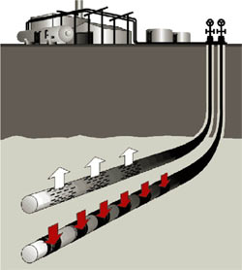
In recent years, companies in Canada have been producing more oil from oil sands as it has become much more profitable. In areas where oil sand is deep beneath the surface, steam process is often used to extract bitumen from the oil sands. This is done by drilling pipes into the ground and releasing hot steam. The steam separates the bitumen from the oil sand and allows it to flow into the lower well, where it is pumped to the surface. Currently this process recovers up to 60% of the oil in place. Because makes it now attainable to extract oil deep beneath the surface, it has quadrupled North American oil reserves and allowed Canada to move to second place in world oil reserves after Saudi Arabia. Investment in development on extracting oil is extremely important to ensure sustainability for Alberta and Canada’s economy. Currently Alberta contains 85% of total bitumen reserves, but only a small amount can be extracted. Even a few percent increase to this total would create a large effect to Canada’s economy.
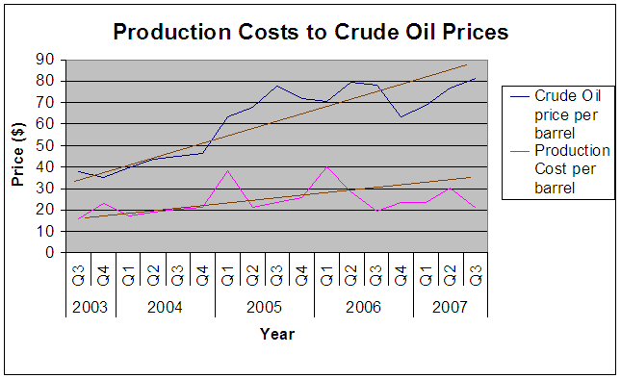
Due to the large inputs costs that oil sands production faces, we found that 28.5% of costs related to processing were based on the current energy costs. Currently the majority of energy for oil sands is created through oil, but because oil sands require such large amounts of power and oil is very costly, power from nuclear plants may be in the near future. Although labour costs have increased significantly over the past few years, they remain an insignificant cost associated with oil sands production as it currently consists of 7.9 %. Energy requirements are much more substantial than conventional oil extraction as there are many process require in the transform of oil sands to crude oil.
Alberta Government calculates that 28 billion cubic metres of crude bitumen are economically recoverable from the three Alberta oil sands, Peace River, Athabasca, and Cold Lake, using at current prices using current technology. Since technology is likely to improve, the estimate reserves recoverable will likely increase.
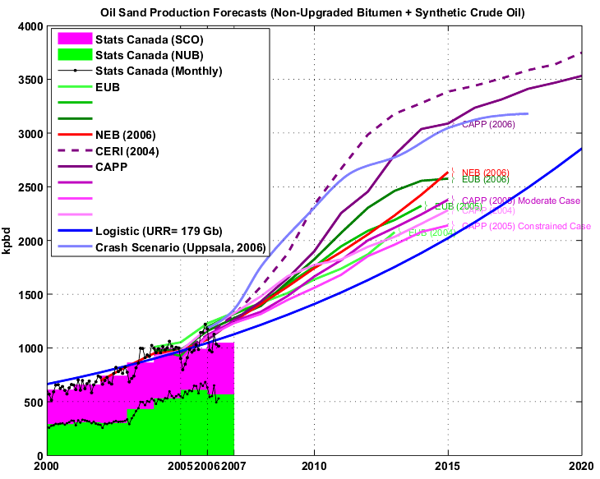
At the current production rates of about 1 million barrels per day, the Athabasca oil sands reserves would last over 400 years. Production from the oil sands is expected to quadruple over the next 20 years, meaning that it will last over 100 years. It is crucial to invest in research and development so that we will be able to extract more bitumen the vast reserves Alberta has. Since only a small portion can be extracted, there is huge potential to grow. Oil sands will help Canada have long-term sustainability in the future, as it is a large driver for Canada’s economy.
Over the last month, the Alberta government has greatly increased the royalty rates, which may have a drastic effect on oil sands production. Producers such as Syncrude, which is strictly in the oil sands industry, will likely have production levels unaffected with these tax increases. Since production levels are already at max capacity, it is unlikely that it will increase its current production levels in order to attain the same profit it once achieved. Other companies such as Imperial Oil (Exxon), Petro Canada, Nexen, Shell and many others may be less willing to invest into large projects, as they not put in the large capital. It is especially difficult for companies who have invested in this area to pull its resources away and is very unlikely since these companies are already producing record profits and would not want to give this away. Because of this the Alberta government has decide to find an appropriate rate since these companies have had long-term leases.
One threat that is relatively unknown that could substantially halt or reduce the oil sand production is water levels. Syncrude as well as other oil sand companies receive its water from the Althabasca River. Since oil sands production requires substantial water use for the separation of sand and bitumen, water could play an important role on production levels. Further, the expansion on new projects in the years to come will greatly decrease the river level. Improvement into technology will help reduce this threat by consuming less water per amount produced and by re-using water so less is required.
The oil sand industry has grown in importance over the last few years to Canada’s economy, and to help promote it and encourage investment, the Oil Sands Discovery Centre offers daily tours of either the Syncrude or Suncor Plant. During the tour, they demonstrate how the oil sands are extracted and covered into conventional crude oil. Tour buses drive down to the actual site where the Oil sands are extracted, which greatly shows the vast size of their operations. The Oil Sand Discovery Center which is much like Science World provides an in depth analysis of oil sands and their significance.
Since Canada has vast natural resources, it will continue to prosper in the future with expansions in oil sand development. The importance of oil sands will become more important to our economy and long-term success.

