1. You are asked to forecast the future return of the stock A. In the past three years, the price change of the stock has been 20%, -5% and 18%. The dividend yield D1/S is expected to be 4%. The dividend growth from past five years has been 2% per year. This is expected to remain the same in the future. The risk free rate is 3%. The expected market return is 12%. The beta of the stock A is 1.6. Please estimate the future return of the stock based on a) The past return data, b) Dividend yield plus dividend growth D1/S + g, c) CAPM model. Which method is likely to provide more accurate estimation? Explain your answers.

Solution:

1. The average price change from last three years is (20% - 5% + 18%)/3 = 11%. The expected dividend yield is 4%. So the total expected return is 11% + 4% = 15%
2. The dividend yield is 4%. The growth rate of the dividend is 2%. So the total expected return is 4% + 2% = 6%
3. According to CAPM the total expected return is Rf + beta\*(Rm-Rf) = 3% + 1.6\*(12%-3%) = 17.4%

Dividend yield fluctuation is much smaller than stock return fluctuation. Dividend yield is always positive. Stock return can be positive or negative. In most cases, the range of dividend is between 1% to 8%, the range of stock price movements is between -20% to 50%. Roughly speaking, the range of stock price movement is an order of magnitude higher.

When we use CAPM, we need two estimates, expected market return and beta of the specific stock. The range of stock price movement, even as a whole is quite high, compared with dividend yield. The estimation of beta is also highly variable. Furthermore, from empirical data, CAPM under estimate return of low beta stocks and over estimate return of high beta stocks. So it is more reliable to use dividend yield plus dividend growth rate as a discount rate in project investment.

The second method is likely to provide more accurate estimate of future returns.

1. The security market is comprised of two risky assets X, Y with return, standard deviation of (10%, 10%) and (15%, 20%) respectively. The market capitalizations of X and Y are 60 and 40 respectively. Suppose the correlation of the two assets are 1, 0 or -1. Please calculate the values of return and standard deviation of the whole market in each of the three conditions. Please calculate the value of risk free rate when the correlation of X and Y are 1 and -1. When the correlation of X and Y is zero, is the risk free rate uniquely determined or not?

Solution:

The proportions of the two assets X, and Y are 0.6 and 0.4. So the return of the market portfolio is 0.6\*10% + 0.4\*15% = 12% in all three cases. Next we will calculate the standard deviations of the market portfolios with different correlations.

1. When the correlation is 1, S.D = 0.6\*10% + 0.4\*20% = 6% + 8% = 14%
2. When the correlation is zero, variance = 0.6^2\*10%^2+ 0.4^2\*20%^2 = 0.01.

S.D = sqrt(variance) = 0.1 = 10%

1. S.D. = |0.6\*10% - 0.4\*20%| = | 6% - 8% | = 2%

We will calculate the risk free rate when the correlation of X and Y are 1 and -1. When the correlation is 1, the relation between return and standard deviation is a straight line.

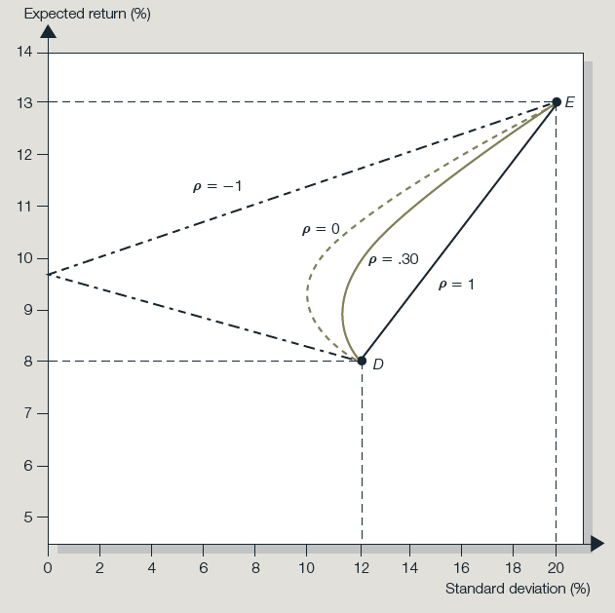

Let the risk free rate to be r. Then (r-10)/(0-10) = (15-10)/(20-10). Solving it to get r = 5 (%). The risk free rate in this case is 5%.

When the correlation is -1, the relation between return and standard deviation is two straight lines, reflected on y-axis. Let the proportion of X is p and the proportion of Y is 1-p when the standard deviation of the portfolio is 0.

p\*10% - (1-p)\*20% = 0

Solving it to obtain p = 2/3. The risk free rate is 2/3\*10% + 1/3\*15% = $11\frac{2}{3}\%$

When the correlation between X and Y is zero, the position of market portfolio is unique and hence the tangent line to the efficient frontier from the market portfolio is unique. The point of crossing to the y-axis is also uniquely determined.

From the above discussion, the risk free rate is not independent from the portfolio of risky assets. There is no separation of risk less and risky. They need to be determined simultaneously. This result differs from the standard theory. This shows that the standard theory is internally inconsistent.

1. Suppose the risk free rate is 4%, the expected rate of return and standard distribution of a risky asset are 8% and 20%. Suppose the utility function of an investor is U = E(r) – 1/2 $Aσ^{2}$. When A is equal to 1 or 2 respectively. Please calculate the investor’s asset allocation ratios between risk free asset and the risky asset.

<https://dqydj.com/sp-500-return-calculator/>

Sp 500 return calculator. Return since 2000, 5% per year.

Sp 500 dividend yield, 7.18,  1950,  1.22, 2000. This alone represent 3.6% capital gain per year.