Introduction

The rising price of gold has caused mining companies to be valued differently depending on what stage of the mining cycle they are in. We will take a look at the difference in valuation for companies that are actually producing gold and those that are currently still in the exploration stage (Juniors). In the early 1990’s when gold was around 400 ounce (check) it was not that profitable to be a gold mining company and not much exploration was going on. As the gold price has continued to rise hitting $1000/ounce it is now very profitable for these mining companies to mine gold. We plan on testing if in a gold bull market would you be better off to invest in shares of companies (producers or juniors) or futures. In theory gold producers prices would rise more than junior gold companies due to their cost structure. We have decided to look at three major producing gold companies and compare them with three junior exploring companies to determine how the gold price affects movement in their stock price. Also we looked at the power of leverage when investing in two gold companies with fixed costs. Last of all we did a study to see if you would be better off investing in futures or shares of a gold company in a commodity bull market.

History
The history of gold began in remote antiquity. Gold was first found by the Paleolithic Man about 40,000 B.C. in Spanish Caves through fossil studies by experts. It was discovered as shining, yellow nuggets in its natural state found in streams all around the world. Because it was the first metal known to humans, it became part of every human culture through its brilliance, natural beauty, luster, great malleability and resistance and because exquisite objects can be made from it because it was not combined with any other metals. The earliest history of human interaction with gold is long lost to us, but their associations with the gods, with immortality, and with wealth itself are common to many cultures throughout the world. Early civilizations equated gold with gods and rulers, and gold was sought in their name and dedicated to their glorification. The Incas referred to gold as the "tears of the Sun." Gold was first found in 1849 in California when $220 million in gold was discovered and since then gold has been with us all our lives in many different ways in symbolizing wealth and guaranteed power.
Gold Price Factors

1) Supply and demand – This is simple economics here. If there is more demand for a product the price will rise. In the last couple years the World Gold council gold supply has been 2500 tonnes while demand has been 3500 tonnes last couple years. Demand can be broken down into 3000 tonnes for jewelry and industrial production and 500 tones by exchange traded funds and retail investors. The excess demand has been filled by central bank sales.

2) US dollar weakness - Historically as the US dollar declines gold increases in value.
3) Price relationship between oil and gold - Over the last 50 years or so, gold and oil have generally moved together in terms of price, with a positive price correlation of over 80 percent. During this time, the price of oil in gold ounces has averaged about 15 barrels per ounce. However, with recent soaring oil prices, the relationship has strayed far from this average. This relationship has recently dropped to the 10:1 ratio. With oil prices recently at all-time high of $110 per barrel, following the ratio that price gold should be US$1,500 per ounce.
4) Economic uncertainties – Whenever people are uncertain of the economy they fall back on gold as a safe haven.
5) Institution buying – This is coming from China and India right now.

Major Gold Companies

GG – Goldcorp Inc

Goldcorp Inc is one of the world's largest gold mining companies with the strongest production growth profile among all major gold companies. It was established on Nov 29, 1954 in Ontario when the name was Goldcorp Investments Limited which later changed its name to Goldcorp Inc on Aug 30, 1991. The corporate office is located in Vancouver, British Columbia which employs more than 9,000 employees. It is the fastest growing, lowest cost senior gold producer. Goldcorp is so big that it has 17 world class operations and projects throughout America with over 70% of reserves in low risk NAFTA countries. Goldcorp was named the best senior gold company in the world in 2006 when it had made over $10 billion dollars in assets.

ABX – Barrick Gold Corporation

Barrick, our second gold company was established in 1983 with operating mines and development projects in North America, South America, Africa, Australia and Asia for a total of 27 operating mines in which it is exploring gold in more than 15 countries around the world. Barrick being a large blue chip producer has the world’s largest gold mineral reserves as opposed to other gold mining companies with 124.6 million ounces of gold reserves, 6.2 billion pounds of copper reserves and 1.03 billion ounces of silver. Barrick’s vision is “To be the world's best gold company by finding, acquiring, developing and producing quality reserves in a safe, profitable and socially responsible manner.”
AEM – Agnico Eagle Mines Limited
Agnico Eagle Mines was formed in 1972 through the merger of Agnico Mines Limited and Eagle Gold Mines Limited. Located in Quebec, with being Canada’s largest gold deposit, it has projects located in Mexico, Finland, USA and of course Canada. With producing more than 4.0 million ounces of gold, they are one of the lowest total cash cost producers in the North American gold mining industry. The company anticipates operating in several multi-mine gold camps globally, while continuing to act in an environmentally friendly manner.

Junior Companies

KXL – Kodiak Gold

Kodiak is a junior exploration company based in Vancouver that trades on the TSX venture exchange. The companies’ signature project is the Hercules gold property in the Beardmore-Geraldton Gold Camp located near Thunder Bay, Ontario. It has a 4.1 million high grade gold production. Recent drilling has shown drill results of high grade along a long strike zone giving KXL a potential for a major gold discovery. Kodiak now has 100% control of more than 1400 square kilometers in the underexplored Beardmore-Geraldton greenstone belt located between the multi-million ounce Red Lake and Timmins gold camps, and the prospects for further discovery appear to be excellent.

JIN – Jinshan Gold

Jinshan, located in Vancouver, British Columbia is a recent gold producer who currently has the 4th largest mine in China. Jinshan started production in early August 2007 and is still in the process of ramping up to full production. Jinshan has proven up a resource of over 3.9 million ounce and current plans are to produce 180,000 ounces per year. Through well-established joint-venture partnerships, operating experience and a strong presence in China, Jinshan is committed to building a significant gold company and enhancing shareholder value. The company has many other exploration properties that have potential to be another discovery.

SKV – Skygold Ventures

Skygold Ventures is an exploration company located 150 km from Prince George but is a Vancouver based resource company. They are drilling hoping to prove up a multi-million ounce resource on Spanish Mountain. The company has been drilling for a couple years now and has yet to produce a 43-101 complaint resource. Skygold controls one of the largest land packages in the Quesnel Trough area and has four new exploration targets named Spanish Creek-Bosk Lake, Prince George, Manson Creek and MT Property.
Results
In our study of Gold, we have come across some interesting facts. We have evaluated and studied 3 major gold producing companies and 3 junior gold companies. As you can see from our table, the 3 major gold producing companies tend to do significantly greater than Gold itself in a 5 year study. Goldcorp nearly doubled its value as Agnico Eagle Mines nearly tripled its value compared to gold. Barrick on the other hand was the only major company that didn’t have much of an increase; it was just a bit lower than what gold’s percent change in 5 years was. As opposed to the junior companies that don’t produce gold yet for the exception of Jinshan, the percent change is in the negatives. This is due to the fact that they are not making any money for their gold as they are not producing it; also they are fairly new companies that are still in the learning process of how to make it big so they have lots of debt at the moment. Another situation in why they are in the negatives could be lack of knowledge of gold.

Companies |  | March 21/03 | March 17/08 | %change | Price Increase
Goldcorp |  | 9.996 | 43.986 | 328.09% | 33.99
Agnico-Eagle |  | 12.49 | 80.29 | 542.83% | 67.8
Barrick |  | 21.68 | 52.86 | 143.82% | 31.18
Jinshan |  | 0.98 | 2.58 | 163.27% | 1.6
Kodiak |  | 2.6 | 2.42 | -6.79% | -0.18
Skygold |  | 0.99 | 0.9 | -9.09% | -0.09
GOLD |  | 347 | 1002 | 188.76% | 655

Leverage

The power of using leverage when investing in gold companies can be very powerful. Gold stock investing is risky but if you are confident enough in the gold price going up you can leverage your investment by investing in mining companies. Let us go through an example of two companies to understand the power of leverage.

You have 2 producing gold companies with everything equal besides cost. We will call one company Low Cost and the other High Cost.

Low Cost uses new technology so its production cost per ounce is $150/ounce.
High Cost is more of a traditional company and has to dig deeper to retrieve its gold so its production cost per ounce is $270/ounce.

For this example we will say gold is selling for $275 ounce therefore Low cost’s profit is $125 ounce while High costs is only $5. Which company do you think is a better investment if Gold increases to $350 ounce? The answer might surprise you.

The gold price is rising 27% when it rises to $350 ounce.
Low costs profit is now $225 ounce and High costs profit is $80 an ounce.
Low costs profit increased 60% from $125 to $225 not bad!
High costs profit increased over 1500% from $5 to $80 even better!
Keeping all other factors constant the stock price of High Cost would increase more than Low Cost. Since earnings drive the share price High Cost shareholders will benefit more than Low Cost shareholders from this.

Futures Example

Say we want to buy 300 ounces of gold at $347 ounce on March 21/2003. On March 21/2008 gold was trading at $1002 ounce. At the time of purchase each futures contract consisted of 100 ounces of gold so we bought 3 contracts (300 ounces). The initial margin for the contract is $4000 dollars per contract (3 contracts * 4000 = 12,000). What would be the total profit of purchasing the 3 contracts if you bought on March 21/2003 and closed out the contract on March 21/2008?

Initial cost = $12,000
$1002 - $347 = $655 profit per ounce
$655/ounce * 300 ounces = $196,500 – $10,000 initial cost = $186,500

Using 30% total capital for risk management purposes
$4000 to invest = 1 futures contract
$655 profit per ounce
$655 * 100 ounces = $65,500 - $10,000 = $55,500

Shares
Shares = $12,000 (Goldcorp)
Price of Goldcorp March 21, 2003 = 9.96
$12,000/ $9.96 per share = 1205 shares
1205 shares * 43.99 price of Goldcorp today = $53007.95
$53,007.95 – $12,000 = 41,007.95

Shares / Futures Comparison
$186,500 – $41,007.95 = $145,492.05 MORE by buying futures… futures = high risk/ high reward though.
$65,000 - $41,007.95 = $23,992.05

Another possible way to manage the risk of buying futures that is common among trades would be to buy in 20% increments. Your initial purchase would be made using 20% of your capital and then you would buy in 20% increments every time the gold price moved up. This would limit your risk when buying futures.

Conclusion

As Gold continues to rise in value there are a few different ways investors can potentially benefit which are shares, futures, and physical gold. Each of the three methods we studied has its advantages and disadvantages. It all has to do with a persons overall risk strategy. The riskier you are the more profitable you will be if right. In order of riskiness our study showed us futures, shares, and then physical gold. Looking at the difference between gold producers and gold juniors we found it more profitable to invest in gold producers as they tracked the gold price closer than the juniors. Our study is limited though only doing six companies and you could see different results if you did a more extensive study. Overall if you believe that the gold price will go up it would be beneficial to invest in anyone of these 3 methods or maybe a combination of them all.

Appendix

Producers

Barrick Gold Corporation (ABX)
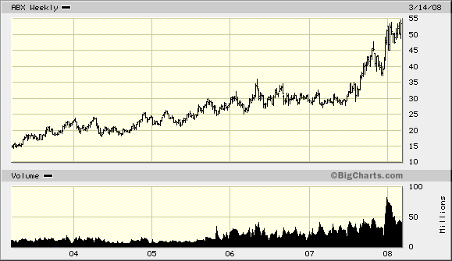

Goldcorp Inc. (GG)
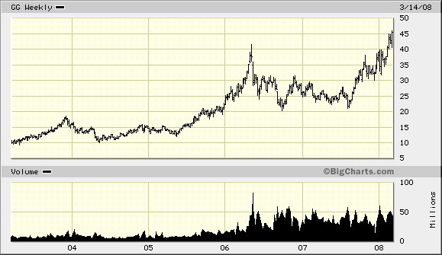

Agnico Eagle Mines Limited (AEM)
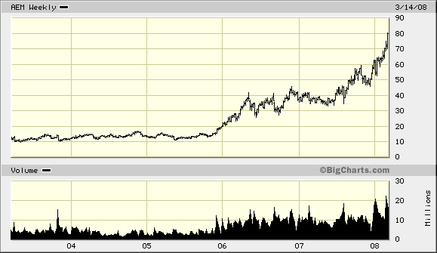

Juniors

Jinshan Gold Mines (JIN)
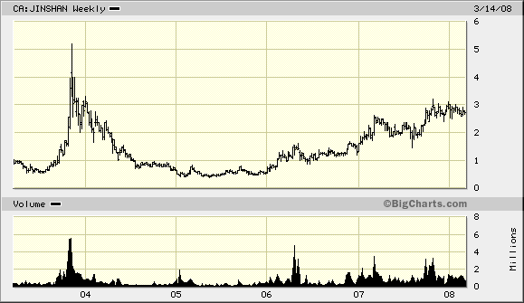

Kodiak Exploration (KXL)

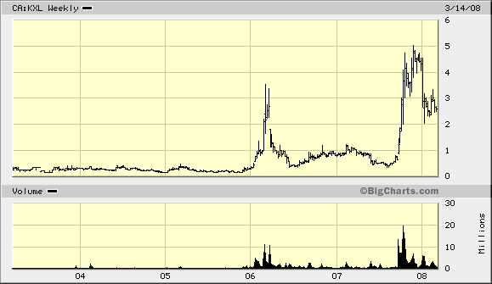

Skygold Ventures (SKV)

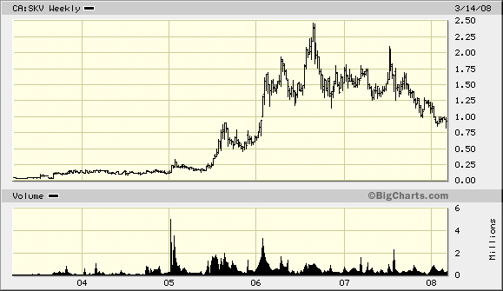

Gold investing risk chart

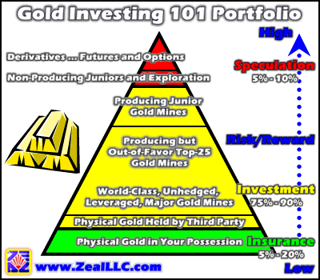

References

Zeal LLC http://www.zealllc.com
Sky Gold Ventures http://www.skygold.ca
Jinshan Gold http://www.jinshanmines.com
Kodiak Exp http://www.kodiak.com
Barrick Gold http://www.barrick.com
Goldcorp http://www.goldcorp.com
Agnico – Eagle http://www.agnico-eagle.com/
Big Charts http://www.bigcharts.com
Jing Chen Comm 423 slides

