The Relationship Among
Fixed Cost, Variable Cost and Return Rate for Online Game Market in China

Course: comm423
Professor: Jing Chen
Students’ Name:
Xiaochen Bian (230044368)
Qiqi luo (230043949)
Due date: 2008-04-03

Contents:
Introduction ---------------------------------------------------------------------------page 3
The9 limited ---------------------------------------------------------------------------page 3
Shanda ----------------------------------------------------------------------------------page 4
Different strategies --------------------------------------------------------------------page 5
Economy --------------------------------------------------------------------------------page 5
Financial Analyst ----------------------------------------------------------------------page 5
Conclusion -------------------------------------------------------------------------------page 8
Table1,2,3 --------------------------------------------------------------------------------page 9
Bibliography ----------------------------------------------------------------------------page 11

Introduction:
World of Warcraft (commonly known as WoW) is a massively multiplayer online role-playing game (MMORPG). Blizzard Entertainment is the company behind the World of Warcraft. It is Blizzard Entertainment’s fourth game set in the fantasy Warcraft first introduced by Warcraft: Orcs & Humans in 1994. The game was released on November 23, 2004, celebrating the 10th anniversary of the Warcraft franchise. It is currently the world's largest MMORPG in terms of monthly subscribers. World of Warcraft was the best-selling PC game of 2005 and 2006. As of January 22, 2008, World of Warcraft has surpassed 10 million subscribers worldwide, with more than 2 million subscribers in Europe, more than 2.5 million in North America, and about 5.5 million in Asia.
World of Warcraft’s appeal lies in that it has created a truly engaging online world.
World of Warcraft is priced differently in different regions of the world. Usually, the pricing model is similar to that of MMORPGs previously released in the market.
The9 limited:
To develop the product offerings and enhance the leadership position in the online game market in China, The9 have obtained exclusive licenses to operate additional MMORPGs in China. The9 limited is primarily focused on operating high-quality games for the Chinese online game market. Since The9 need huge money to operate World of Warcraft; in Dec 2004 The 9 limited priced its IPO on Nasdaq. WOW has commercially launched on June 7th, 2005 and in July 2005 WOW has exceed 1.5 million playing player in China. The 9 limited signed agreement with Blizzard Entertainment to a new path (the burning crusade) in China in Jan 2007.
Culture different:
The Chinese government and The9 have to make some change in WoW. These changes were imposed by the Chinese government in an attempt to "promote a healthy and harmonious online game environment" in World of Warcraft. However, these change will be come a part of the cost. To suit for Chinese culture, The9 have to increase the cost to do some change. In fact, Chinese support for develop online games. Chinese government technology department have invested US $700,000 to support online game. $ 700,000 is really not enough for an online game industry, but the real meaning is that Chinese government regard and support for the online game industry.
Shanda:
Shanda is the biggest company to run online games in China. The company provide online games for entertainment. Most of the game is exploitation by them. Same as The9, Shanda most of game is role play games. For the Chinese national games, Shanda has a large market. In 2004, Shanda priced its IPO on Nasdaq. The opening price is $11 dollar. The company’s IPO total collect money are 150 million dollars. Shanda knows well about Chinese market. They know what customers need is. Some company also exploitation games, but they want return in a short term. Shanda is more focus for a long term investment.
Different strategies:
However, stock is not the biggest gains for The9 to operate World of Warcraft. The9 as an agency of WoW, this firm can earn a famous brand. The9’s strategy is to agency classical online games. However, Shanda is a company that exploitation games by them. Compare with those two companies, we can see The9 is going to a gambling way in China online game market.
Economy:
Because the game industry in booming, China is a hot point for the US investor. So does Blizzard Entertainment. Blizzard entertainment bring up harsh conditions, but how come The9 still happy to sign the contract? There are two reasons: the first one is to continue their product and the second one is their stock market. In Dec 2004 the 9 limited priced its IPO on Nasdaq. In the first day, the opening price is US $19 and the closing price is US $21. It is US $4 higher than opening price. Margin is increase to 23.53%. Because of capital strategy, the9’s market value is over one hundred million. To accompany World of Warcraft release in Chinese market, the9’s stock is still rising in a long period. The9 became the only one stock for Chinese online game that keep rising in Nasdaq. The highest stock price is over $30 dollars.
Financial Analysis:
The level of fixed investment in a project (fix cost) depends on the expectation of the size of the market. If the investors predict that the market size is large, they should invest in the projects with high fixed cost, unless they may suffer a higher operating cost (variable cost). Thus, the limited revenue growth rate with increasing cost will lower the net income.
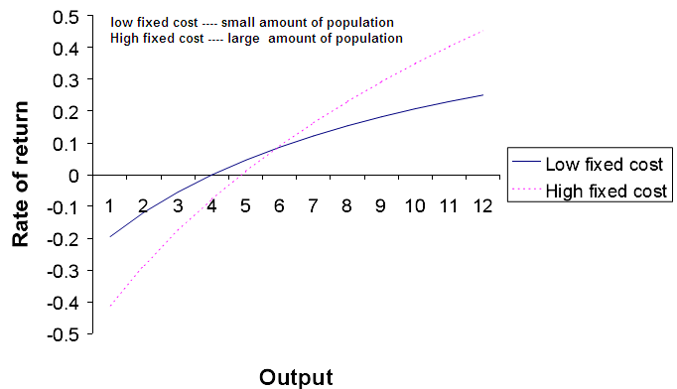
From the figure, we can clearly see that with a higher fixed cost, the return rate is higher due to long term, and a project with a lower fixed cost, the rate of return is lower.
In this paper, we mainly compare two online game entertainments: The 9 Limited, a company primly operates games by buy license from other game makers, and Shanda Entertainment, a company that develops games itself and operates games it self. As we described, The9 Limited and Shanda both are the leading online game entertainment companies in China, but with different strategies. The table below compares the two companies’ total costs.
From Table 1 (The9 annual income statement from 2003 to 2007), we can see that after The9 launched WOW in 2004, we can see The9 entered a high gross time during 2004~2007, the total Operating Cost increased sharply due by the large cost on game royalties, and the expenses of software support from Blizzard because of the largely increased market size. Especially 2007, the total Net Income decreased from 1st Quarter, even though the total Revenue is increasing. (Table 2. The9 quarterly income statement for 2007) Up to 3rd Quarter 2007, the Revenues gross profit increased 17% compared 2nd Quarter; the operating expenses increased 19% compared 2nd quarter and the Net Income decreased 31% compare to same quarter for 2006. All those statements represent that operating Blizzard’s WOW will not be a high profitable project in future long term when the market size continually goes larger (the demand of computer equipment, software support, and game operating support goes larger).
Unlike The9, what Shanda’s focused on online games is on product development. We should recognize that software development costs (fixed investment) for development of software to be market to customers are large; moreover, the variable costs are amortized over the estimated product life. The9’s lose is not due to the bad game operating, but due to the high cost on all subsequent software costs from Blizzard. From Table 3 (Shanda annual income statement from 2003 to 2007), we see Shanda’s did spend huge money on Equity in 2005 (544 Millions equal to 30% of its total Revenues in 2005). And the operating Cost, Revenues and Net Income increased with a stable rate because of develop subsequent software by itself won’t cost much money. After the product was released, Shanda’s operating costs are mainly on computer equipment when the market size goes larger.

Conclusion:
The9 have to adjust online game industry structure since agency firm is in a major position in game industry. The9 spend all the money to investment World of Warcraft is kind of risky. The firm do not have any other income to support company. Nobody knows World of Warcraft will still make money for The9 5 years later. Once WoW costs are bigger than revenues, The9 will bankruptcy. For example, if you have a 1994 Honda car. The car that you already used 14 years, and it will charge you more repair cost than when you just bought it. When you feel the repair cost increase to really high, and you can not get more benefit from the car. You will decide to buy a new car instead the old one. The9 should change structure to make the market structure more international. Manufacture’s source can from different channel. Shanda is doing better in here. They have their own online games and they do not just support one game. The company is preparing to develop international market. The9 does not have a future plan to develop other online games to instead operating World of Warcraft as an agency. The firm more lead to gambling way since they spend huge money to operate World of Warcraft.

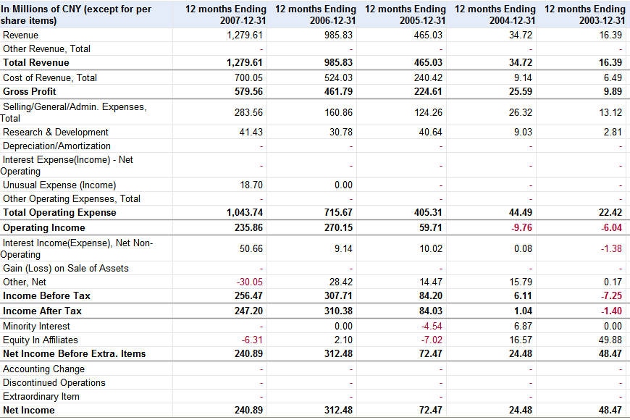
Table 1. The9 income statement from 2003 to 2007 (annual)
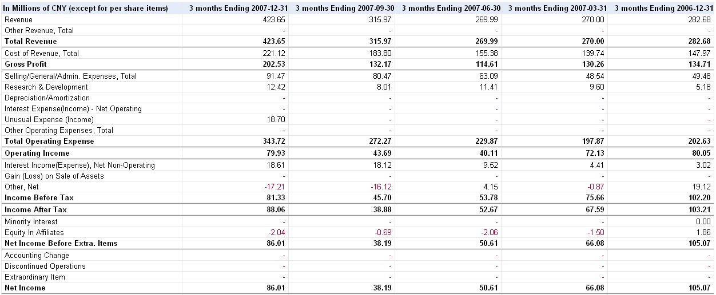
Table 2. The9 quarterly income statement for 2007

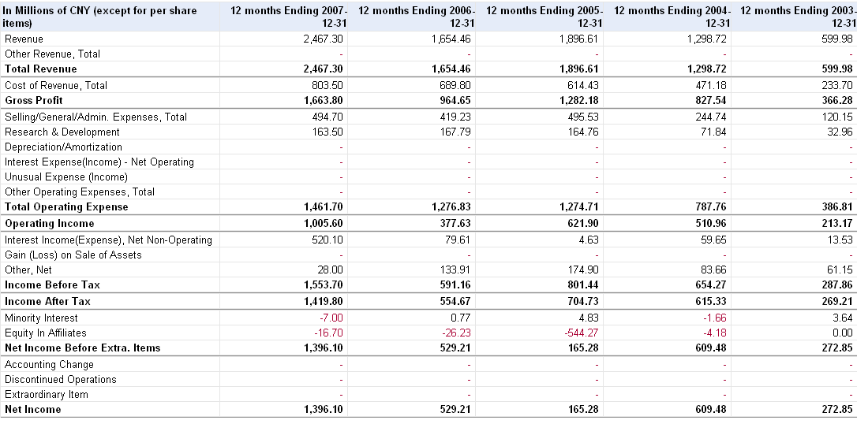Table 3. Shanda income statement from 2003 to 2007 (annual)

Bibliography
1. http://www.gamespot.com/news/6110140.html?print=1
Games set to heat up the Chinese economy
2.http://www.wowinsider.com/2007/07/03/the9-changes-wow-in-china-to-appease-censors/
The9 changes WoW in China to appease censors
3. Jing Chen. “An Analytical Theory of Project Investment: A comparison with Real Option Theory”, 2006.
4. http://www.snda.com/en/investor/annual_rep.htm
Shanda annual report
5. http://www.the9.com/en/IR/sub_6.htm
The9 annual report

