THE VENTURE EXCHANGE
By James Fraser and Darren Falk

In the past, the TSX Venture Exchange was Canada’s little known market change. However, though the TSX may be the smaller in statue, it is extremely profitable. According to statistics over the past few years it has seen more growth than all other large indices in the world. With such growth occurring, it is hard to over look this market index.
History:
The Venture Exchange is a conglomerate of small Canadian stock exchanges. It has historical life span of mergers and acquisitions. In 1999 through realignment the Alberta and Vancouver, Montreal and Winnipeg exchanges all merged together to form the Canadian Venture Exchange (CDNX). Along with this merger came the responsibility of handling trading responsibilities for Canada’s emerging companies. In 2001 the CDNX was acquired by the Toronto Stock Exchange to form the TSX group. However, the stock exchange still retained it is responsibilities, but was renamed the Toronto Venture Exchange (TSXV).
The TSX Venture:
Those that list on the Venture Exchange are small and emerging companies known as junior companies. Many of these companies associate themselves with large amounts of risk because of their weak financial position. Listing on the Venture is one way to increase their capital to meet the costs of doing business in its industry. Junior companies often are those who do research or exploration with hopes that their findings will entice an established company to take them over. If this is not the case the TSXV is a stepping stone for companies to gain an increased market share and graduate to the Toronto Stock Exchange where they can have access much larger venture capital pools.
More and more companies are beginning to see the Venture as viable option in their quest for growth. According to the TSX group there are approximately 2200 companies that trade on this market. Its issuers are come from a diverse mix of industries which include: biotechnology and financial services. However, the largest contributor of issuers is the resource sector. Figure 1 shows the breakdown by percentages of industries listed on the Venture Exchange.
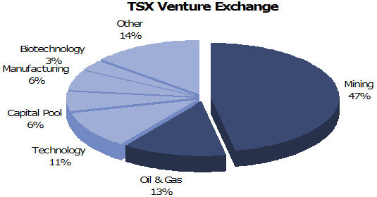
(Energy and Capital 2007)
Statistics show that 60 percent of the companies are involved with oil and gas or mining. With such a concentration of commodities it is understood that scarcity plays a role in the Ventures increased growth.
The Risks of the Venture:
There is no comparison between the TSX Venture and the TSX in terms of the amount risks associated with each market index. Most investors consider the Venture unstable and very risky to invest in. The question is what is rationale of this increased risk? There are three probable explanations:
- Lack of industry diversification- 60% of listed companies in oil and gas or mining. The concept of individual portfolio theory to this index as whole. The more diversified a portfolio the more stable it will be. Due to its collection of commodity companies the Venture often sees large systematic price swings.
- Companies are in the early stages of their life- are often not very profitable or even showing losses as they list on the venture exchange. It does not take much too greatly affect the companies and lower their stock price.
- The primary objective of listed companies is exploration or research- listed companies stock prices are based around speculation of their results or findings. If the findings are not good then stock prices will drastically drop.
How to get listed?
The TSX venture offers companies a two tiered system with different listing requirements that depends upon the industry sector, stage of development, financial performance, and operational resources. Companies have four different ways of going about getting listed on the exchange. The first method is by issuing an Initial Public Offering (IPO). An IPO requires filing a detailed prospectus that will provide investors with detailed information on the company. After completing the prospectus and filing it with the securities commissions the next step is to complete an application for a public listing. Another way to get listed is called a direct listing which is if the company is already listed on another exchange and meets the ventures listing requirements already. An interesting way to file would be the reverse takeover method which is basically joining forces with another company already listed. The last way a company can list is by Capital Pool Company (CPC) which is exclusive to the venture exchange. A CPC is a two step process first of which is to create the CPC and then to sell the shares. Creating the CPC involves several individuals coming up with a minimum of $100,000 in seed money. These founders create a shell company and issue shares in exchange for the seed capital. The CPC and its advisors the provide a prospectus outlining how it will raise more money (200,000 to 1.9 million) by selling shares at twice the seed capital price. They will then use the proceeds to identify and evaluate possible acquisitions. After filing the prospectus the CPC applies to be listed on the exchange. The broker then sells the shares and the company is listed on the exchange (note with a .P to indicate it’s a CPC). The second process is that within 24 months the CPC is required to announce via a news release an acquisition of a business. After the deal is closed the .P is removed from the companies and it trades as a regular company.

Benefits of getting listed:
The five benefits of getting listed are:
- Access to capital – provides opportunities for continuing operations, acquisitions or growth. The number of shareholders will increase which provides a base for second financings if needed in the future.
- Public awareness- increased coverage from the media brings greater awareness of the company to the public. With the increased coverage more people will know about the stock therefore potentially bringing in more investors (more demand) that could increase the value of the stock
- Liquidity - Allows for shares to be traded easier and faster in a regulated environment. Has the potential to lead to greater value then in a private transaction.
- Stock options – Employees can take part in owing part of the company. The company can use this to its advantage for many things including bonuses, employee share purchase program, an incentive to increase productivity and efficiency (example WestJet), and also in recruiting people.
- Growth – Companies can use shares instead of cash to acquire other companies. Using shares can be used as a tax efficient vehicle.

Trends:
The venture exchange has been on an upward swing for the last 5 years tripling in size from an index value of 1000 to around the current value of 3250. The growth of the venture since 2002 has greatly outpreformed the returns on the US indices - the Dow Jones, NASDAQ, and the S&P each of these indices have returned about 20% overall since 2002. What about the other entire world indices? The only other exchange that comes close to the venture would be the Hong Kong Hang Seng exchange which has gone from 10,000 to 35,000. As you can imagine the venture is a high risk/ high reward exchange.

5 Year Chat – TSX Venture Exchange
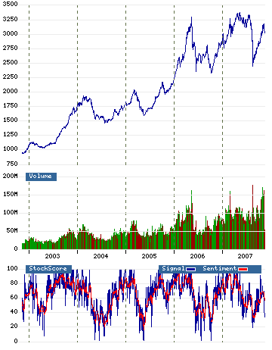

The venture exchange has been on an upward swing for the last 5 years tripling in size from an index value of 1000 to around the current value of 3250. The growth of the venture (300%) since 2002 has greatly outperformed the returns on the US indices - the Dow Jones, NASDAQ, and the S&P each of these indices have returned about 20% overall since 2002. What about the other entire world indices? The only other exchange that comes close to the venture would be the Hong Kong Hang Seng exchange which has gone from 10,000 to 35,000. As you can imagine the venture is a high risk/ high reward exchange.

Venture Success:
Why has the venture enjoyed such a high return in the last five years? With the venture exchange being composed of 60% metals and energy companies it is no doubt why it has had great success the last five years. We have come up with two main reasons for the tremendous rise which are: commodity prices and the increase in the Canadian dollar. The obvious answer is the increase in commodity prices such as gold, oil, silver, copper, zinc and other precious metals. With half of the companies listed on the venture being involved in the mining industry and over 10% being involved in the oil industry the increase in commodities has driven their shares much higher. A lot of these companies are not even close to being in production and are in the exploration phase on their properties. Before the increase in commodity prices a lot of these junior companies were not as active as with the prices what they were it was not even feasible to attempt to get the metal out of the ground. The share price for juniors is driven largely by speculation and what the company has found in the ground. It is not unusual for a junior resource company to double its value on drill results that are favorable to the market. Another factor that bodes well for the venture exchange is the increase in the Canadian dollar especially in the last year.
Local Spotlight:
A few of the local companies (prince george area) listed on the tsx venture exchange are Skygold resources (SKV.V), TTM resources (TTQ.V), and Terrane Metals (TRX.V). Skygold is involved in developing a potential multi million ounce gold deposit on Spanish Mounatin in Likely B.C. TTM resources is drilling for Moly at its Chu Molybdenum project which is located 80km southwest of Vanderhoof. Terrane Metals is developing their Mt. Milligan gold-copper project 155 km northwest of Prince George. All these companies are typical examples of the types of companies listed on the venture with their share prices between 40 cents and $1 and the market caps ranging between 20 and 45 million.
Conclusion:
The Venture exchange has had tremendous growth in the last five years with the commodity super cycle. This growth will continue as long as commodity prices continue to increase which many people predict they will. The companies listed on the venture tend to be high risk with the potential for high reward but if you know what you’re doing you can make some serious money. We learned from value theory that the more scare something is the higher the value is so we apply it in this way: the more scare metals become the higher metals prices will be therefore higher share price for these juniors on the TSX venture exhange.

Sources

Energy and Capital . Burgess, Luke. March 13, 2007. November 11, 2007. http://www.energyandcapital.com/articles/tsx+venture-energy-minerals/380
The Venture Insider. 2007. November 10, 2007. http://www.theventureinsider.com/.
TSX Group. 2007. November 09, 2007. http://www.tsx.com/

