Dubai

Jeffin Raju
Shayna Mason

Comm. 421
Jing Chen
November 16, 2007

Table of Contents
Intro…………………………………………………………………………………1

Current Trends……………………………………………………………………....1
- GDP Growth between “2000-2005”………………………………………...2
- Per Capita GDP Growth…………………………………………………….3
- Economic Growth…………………………………………………………...3
- Sectoral Performance………………………………………………………..3
- Tourism……………………………………………………………………...4

Where does the money come from?...........................................................................5
- Oil……………………………………………………………………….......5
- Tourism……………………………………………………………………...6
- International Finance Center………………………………………………...6
- Shipping………………………………………………………………….….7
- Airlines and Airports………………………………………………………..7
- Strategic Location…………………………………………………………...7
- Banking Industry……………………………………………………………8
- The Commercial Banking Sector……………………………………………8

Why companies go to Dubai………………………………………………………..9

Negative Impacts of Economic Growth……………………………………………10
- Inflation …………………………………………………………………....10
- Cost of Living………………………………………………………...…….10
- Emiratisation………………………………………………………………..11
- Labor Wages………………………………………………………………..12

Future of Dubai…………………………………………………………………….12

Appendix…………………………………………………………………………...13
Figure 1: Dubai GDP at Current Prices (USD Millions) 2000……………………..13
Figure 2:…………………………………………………………………………….13
Figure 3: Non-Oil industries contributions to Dubai’s GDP……………………….14
Figure 4: Inflation (CPI Growth)…………………………………………………...14
Figure 5: UAE Inflation…………………………………………………………….15
Figure 6: International GDP Growth vs. Population Growth………………………16
Figure 7:…………………………………………………………………………….16

Bibliography……………………………………………………………………….17

Intro
Dubai is a small Middle Eastern region that belongs to the United Arab Emirates. The UAE was formed in 1971 all emirates are governed by a Supreme Council of Rulers; however each emirate is still largely independent (“United Arab Emirates”). Sheikh Zayed, president of Abu Dhabi, over saw the initial export of oil and recognized the importance of building healthcare, and education systems in the area (“United Arab Emirates”). The UAE grew very quickly as their oil production boomed. The United Arab Emirates is one of the largest oil producers in the world and they have used oil revenues to create a very diverse and unique economy (“United Arab Emirates”). Dubai is a considered the hub for global finance, trade, and tourism; it fills the gap between Europe and Asia. Halliburton a large oil company is moving is headquarters to Dubai in order to take advantage of its close proximity to one of the largest energy markets in the world – Asia (ABC News). Because Dubai and the United Arab Emirates are rapidly growing there are many fascinating developments in tourism and construction. So where does all the money for the development of a country come from? The answer surprisingly is not just oil revenues but from tourism, finance, and shipping as well. In the future Dubai and the UAE will have to find ways to control inflation and manage the labour force in Dubai in order to have the man power to continue its development.
Current Trends
So, what’s happening in Dubai currently, with the second largest amount of cranes in Dubai after China, with 15-25% of the world's construction cranes in operation I think we know the answer, Construction!! About 30,000, or 24 per cent of the world's 125,000 construction cranes, are currently operating in Dubai. The demand for construction related machinery, equipment and vehicles is expected to continue rising in the Middle East, especially in the UAE, due to the continuing construction and real estate boom.
In 2003, the UAE's market for heavy construction machinery stood at $165 million, road construction machinery at $142 million and earth moving machinery at $125 million. The size has increased by 15-20 per cent since then. There was almost $300 billion worth of projects underway in the UAE, according to a recently published report. Dubai's current success has been a result of its bold and visionary leadership and innovative human resources, mainly driven by government policies aimed at improving the business and investment environment, in addition to initiatives to establish specialized zones and mega projects (e.g. Internet and Media City, Healthcare City, The Palm, Dubai land, etc).
Those developments ensured a leading role for Dubai and helped attract excess regional liquidity in the form of Foreign Direct Investment (FDI).

GDP Growth between “2000-2005”
Dubai's historical economic growth has been truly impressive. In particular, since the year 2000, real GDP has been growing at a compounded annual growth rate of 13 per cent, by far exceeding that of its GCC counterparts. The Dubai economy has also been growing faster than the emerging economies of China and India, and the developed economies of Ireland, Singapore and the US.

Per Capita GDP Growth
The factors discussed above have put Dubai's real per capita GDP at Dh114,362 ($31,140) in 2005, with an annual average growth rate exceeding six per cent over the 2000-2005 period. Dubai's per capita income today compares very favorably with that of many developed countries such as Singapore [Dh98,555 ($26,836)] and Hong Kong [Dh93,623 ($25,493)], countries which required a much longer period of time to reach their current levels.
Economic Growth
Economic growth has also been fuelled by private sector participation in developing sectors for which the government has set the stage by establishing business environment, coupled in many instances with heavy initial investments to boost private sector confidence.
Other supporting factors are supply-side factors such as availability of labour and land for major real estate projects; the existence of efficient government services; a solid institutional framework and good mechanisms for service delivery; strong laws and regulations; excellent infrastructure, a strategic location coinciding with the rapid rise in global trade, especially in China and India, and openness to other cultures, giving Dubai a reputation as a safe and comfortable place to live and do business.
Sectoral Performance
Economic performance at the sectoral level has also been notable. The non-oil sector played a more prominent role in 2005 with a 95 per cent contribution to GDP, compared to 90 per cent in 2000.
This was mainly the result of the reduced dependence on oil as well as a deliberate policy of diversifying the economy in favor of the non-oil sectors in which both the overall business environment and sector-specific programs have played vital roles in developing and taking Dubai to the level it is now. The service sector has been the key driver of economic growth with an annual growth rate of 21 per cent since 2000, constituting Dh101.4 billion ($27.6 billion) or 74 per cent of Dubai's current GDP in 2005.
The construction and real estate sectors have also exhibited share gains, primarily due to the availability of land, labor, domestic and foreign capital, and changes in regulations.
Dubai's current GDP mix is very favorable, as its strongest sectors by international standards happen to be highly conducive to future global growth. These sectors are tourism, transportation, construction, and financial services, and are well placed to constitute the focal point of Dubai's future growth path within the economic development sector plan.
Tourism
The city has 46,775 rooms in 439 hotels and serviced apartments now compared to 40,862 rooms in 313 properties in 2006. Dubai has added around 5,900 new hotel rooms this year and it expects to grow the current number of guest accommodation units by a staggering 172 per cent to accommodate the targeted number of 15 million visitors a year in 2015. The city at present has 46,775 rooms in 439 hotels and serviced apartments compared to 40,862 rooms it had at the end of 2006 in 313 properties, according to Dubai's Department of Tourism and Commerce Marketing (DTCM).
"By 2016 the number of hotels and hotel apartments is set to rise by 29.2 per cent to 554, with the room capacity within the same period expected to grow from 46,775 units now to 127,000," DTCM said at the World Travel Market.
As many as 95 Dubai companies are taking part in the travel industry event under the tourism department's umbrella. Tourism contributes 30 per cent to Dubai's economy and will play a major role in the emirate's target of tripling its gross domestic product (GDP) to $112 billion by 2015. Dubai's hotels and apartment hotels last year received about 6.5 million visitors that contributed $3.5 billion to the emirate's economy.

Where does the money come from?
Oil:
Oil is a very large part of the economy of Dubai. Oil is an extremely valuable resource and the Middle Eastern economy was basically built on the production and exportation of oil, which began in the early 1960’s. There has been a transformation that has taken place in the region since the discovery of oil and growth has been and continues to be very rapid. This growth is expressed in the 8% average annual GDP growth of Dubai. Despite the earning power of the oil industry Dubai and UAE is forward thinking and have used oil revenues to further develop other industries in the area. The oil industry accounted for 10% of Dubai’s total GDP in 2000, in the year 1980 the oil industry contributed to 55% of the total GDP. Decreasing the reliance of the economy on the oil industry will only help strengthen the stability of the country and the growth that it experiences on an annual basis.

Tourism:
Dubai has uses the large oil revenues to invest in projects that promote tourism in the area. The tourism industry is becoming more important and is being used in order to build a national identity for Dubai. Dubai is quickly making a name for itself in the global community by competing with Las Vegas for the title of tourism capital of the world (Jones). Dubai is home to many tourist attractions such as the palm islands and some of the largest skyscrapers in the world. Due to a high volume of visitors Dubai had the highest hotel occupancy rate in the world of 86% in 2005 (Jones). Dubai also boasted the highest hotel revenue per guest in that same year (Jones). With the highest number of tourists and the highest revenue per tourists visit, it is very to see that Dubai has a valuable hold on the tourism industry.
International Financial Center:
The Dubai International Financial Center opened in 2004 and provides complete financial services to the region and the world (“Regional Opportunity.”). The Dubai International Financial Exchange opened in 2005; it is the connection between the major financial markets in the world (“Regional Opportunity.”). Because of its central location the DIFC is operational round the clock. The financial center is comparable to the major capital markets. Dubai offers a 0% tax rate on income and profits, 100% foreign ownership, and no restrictions on foreign exchange or capital/ profit repatriation (“Regional Opportunity.”). Before the financial center was created there was a large gap between the financial markets in Europe and those in Asia, DIFC looked to provide the 2.1 million people, who were in the region, with financial services (“Regional Opportunity.”).
Shipping
Dubai Port Authority has been ranked amongst the leading and most advanced container ports in the world, which has the capacity of serving more than 125 shipping lines and container traffic of 3,501,821 TEUs and total tonnage to 47 million tones. Between them, the twin terminals of Jabel Ali and Port Rashid handled 11,293 vessels in 2001, including 4,942 container vessels.

Airlines and Airports
Emirates which is Dubai’s official airlines has been the only airline company who made a profit during the events of 9/11. Emirates recently announced a record net profits of US$ 750 million, which is 23.5 % increase in profits compared to the previous year. Dubai based Emirates Airline is one of the fastest growing airlines in the world and has received more than 300 international awards for excellence.
Dubai International Airports have grown from having nine airlines serving twenty destinations in 1969, to be able to accommodate more than 90 airlines and connecting over 140 destinations. Total of thirteen million passengers passed through the airport in 2001, an increase of 10% over the previous year. It is anticipated that by 2018, Dubai would have 45 million passengers and have an expansion of US$ 600million.
Strategic Location
Dubai is located at the midway between Europe and Far East Asia, which lead to high demand in export, import, and re-export market and a surge in visitors to the country. Hence, it is not surprising that 12% of Dubai GDP is contributed from the Ports.

Banking Industry
According to the latest UNCTAD in the 2006 World Investment Report, the number of Greenfield projects in the UAE has risen by 144%, from 88 in 2002 to 215 in 2005. FDI inflows on the other hand rose to US$12bn in 2005, up from US$8.4bn in 2004 and US$4.3bn in 2003. The UAE is the clear leader in attracting FDI, dwarfing inflows into Saudi Arabia of US$4.5bn and US$1.5bn into Qatar. Reflecting the UAE's investment in overseas assets and diversification efforts, FDI outflows have also seen a major climb from US$0.9bn in 2003, to US$1.0bn in 2004 and US$6.7bn in 2005. Moreover, FDI flows as a percentage of gross fixed capital formation have more than doubled since 2003, from 21.4% to 51.8%. Meanwhile, FDI stocks as a percentage of GDP have risen from 2.2% in 1990 to 21.2% in 2005, though the UAE has some catching up to do here compared to Bahrain's 64.1% and Lebanon's 68.5% in 2005.
Inflation remains a significant concern, despite our 6.5% average CPI forecast for 2007, down from an estimated 10% in 2006. Moderating oil prices and administrative controls on rent, and potentially on juice and dairy, will provide short-term respite, but structural issues persist. US dollar weakness has fostered rising imported inflation, particularly given the growing importance of the EU and East Asia as trading partners. However, in the longer-term, exchange rate reforms, such as an upward revaluation, remain plausible, while our core scenario does not foresee substantial further dollar declines.
The Commercial Banking Sector
Economy in general, the banking sector is growing quickly. Total banking assets reached US$207bn by September 2006, with a growth rate of 25%.At this rate, total assets will reach over US$632bn in 2010. To September 2006, loans grew by 34% and deposits by 25% the loans/deposits ratio reached 112.3%, and is continuing to trend upwards. The loans/assets ratio, on the other hand, is a relatively conservative 57.4%. What is important about the increase in loans is that the largest growth (194% since 2003) has been in personal loans for business purposes, representing investment where the economy most needs it. Private investment is a critical driver for sustainable growth.

Why companies go to Dubai:
Dubai has emerged as a leading regional commercial center with state-of-art infrastructure and a world class business environment. It has now become the logical place to do business in the Middle East, providing investors with a unique and comprehensive value added platform. With its strategic location, tax-free living and consistently strong economic outlook, Dubai is the ideal base for multinationals targeting markets in Central Asia, the Middle East, Africa, the Asian Subcontinent and the Eastern Mediterranean. These regions have a population of over 2 billion people and a combined GDP of US$ 6.7 trillion. Accessible through its ultra modern airport, that offers connections to over 140 destinations, Dubai is also a thriving tourist destination and attracts a large number of skilled professionals. Its robust economic cluster of technology, media, and finance and healthcare hubs makes Dubai a viable and attractive proposition for any business.

Negative Impacts of Economic Growth
Inflation
Surging inflation is denting the UAE's global competitiveness, according to a survey released yesterday by the World Economic Forum. U.A.E ranks 37th in the Global Competitiveness Report 2007-08, the same position it held last year and below Saudi Arabia, Qatar and Bahrain. UAE is one of the many regions’ most competitive economies with a flexible labour market and modern transport infrastructure. But they say rising inflation of 9.7% is a big issue concerning the residents of Dubai and insufficient progress on economic reforms - a common factor in the region - is holding back its potential.
The rising money supply, costs associated with inflation and surging speculative investments in domestic markets are putting pressure on the UAE and other GCC countries to adopt more flexible currency policies, according to two international banks.
According to Merrill Lynch’s currency strategist Emma Lawson "We believe there is a significant risk of a change in the policy regimes of either the UAE or Qatar in the coming six months. We continue to hold a long dirham and Kuwaiti dinar versus short dollar in our discretionary portfolio,"
Cost of Living
Thanks to the high inflation, its been hard for the middle class families to survive in a booming country like U.A.E. Since there is no restriction on price increase, rent caps or other financial regualortories that are available in most of the developed countries, the cartel try to maximize the benefit of this as much as possible. This ranges from the landlord who increases the rent every 3 months, to the grocery store guy who increases the price of bread by 150% to the high end stores. But, it’s the middle class people, who are getting affected by this, not the rich. Dubai, has turned into a country of rich people, everybody know Dubai by the riches, no body realizes that all this was built by the hardworking labor who work at 50 degree Celsius outside and get paid 150$ a month. In the end, if government does not take necessary steps, major labor and other working class people would leave the country and go back to their own country. Especially, when there is no more motivation for people from the India and China, since these countries are developing at a fast pace rate. The cost of living is more expensive that Switzerland.
Emiratisation
It’s a movement by the government of U.A.E to proactively employ its citizens in the public and private sectors to reduce its dependence on foreign workers. The main issue is that UAE creates 800,000 new jobs every year, yet there are 36,000 UAE nationals seeking jobs with more than 15,000 fresh university graduates entering the work force every year. The vast majority of those benefiting from the creation of the new jobs are expatriates, leaving a significant number of qualified and skilled UAE nationals without jobs. Such is the severity of the situation that the World Bank and IMF have both pointed to unemployment as a major hindrance to development in the Arab world, including the UAE.

Labour Wages
There are no minimum wages in U.A.E., therefore the labour are exploited by many construction companies, who makes huge profits by the low wages that they provide. On average labours get paid like $100-150 if you are lucky. This can be a huge issue, if it is let go like this, because, a booming economy in India, also means that many there no longer see the need to travel to Dubai and other Persian Gulf cities, since majority of the labour are from India and other Asian countries. The federal government recently has announced a review on this issue.
Future of Dubai
The future of Dubai looks very promising as the region continues to grow very rapidly and consistently. Dubai is also looking to ensure a stable economy by diversifying its investments and expanding other non-oil producing industries. But, there are certain rules that need to be changed to make sure that there is enough labour to work in the country. Governments should realize the needs of the poor, and not just keep on getting multi billion dollar projects, that would just increase inflation and cost of living.

Appendix
Figure 1
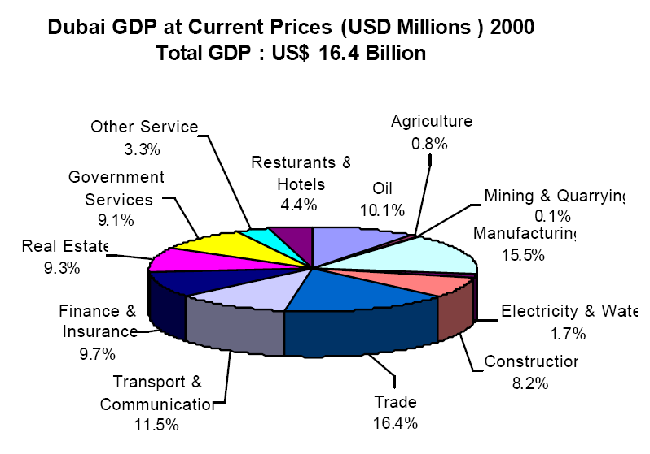
Figure 2
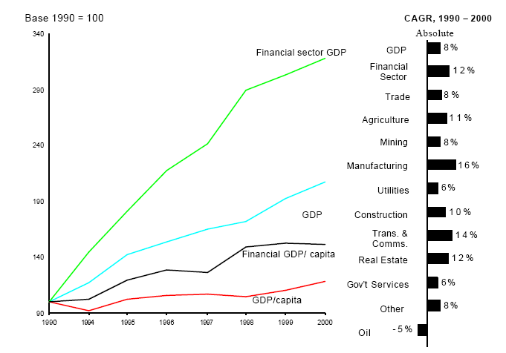
Figure 3
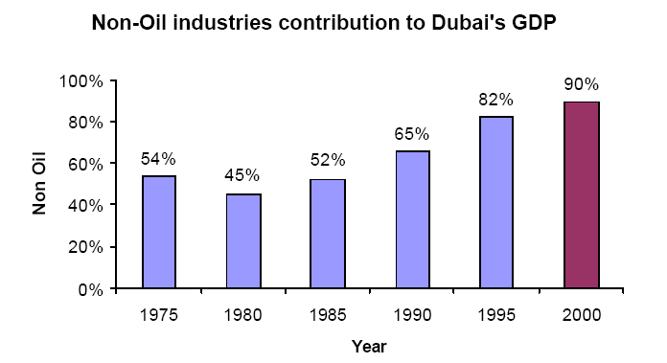
Figure 4
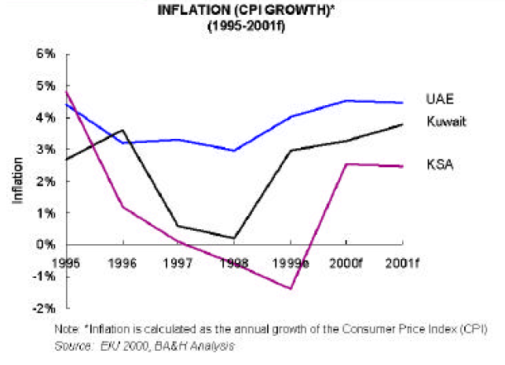

Figure 5
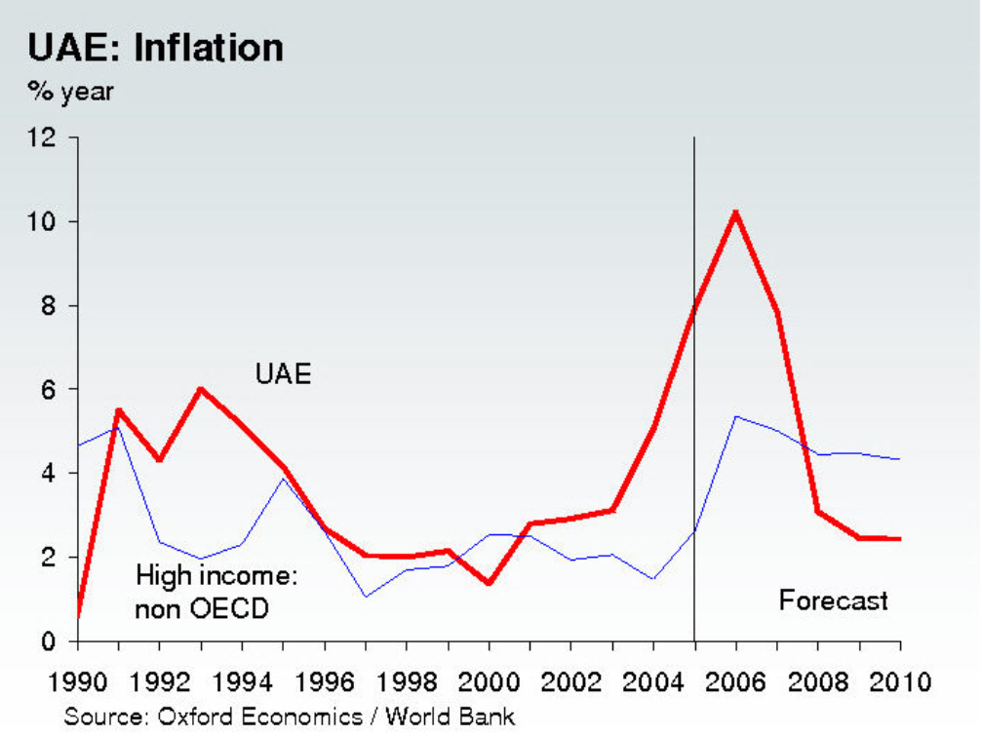
“United Arab Emirates.” Oxford Economic Country Briefings 14 June 2007

Figure 6
International GDP Growth vs. Population Growth
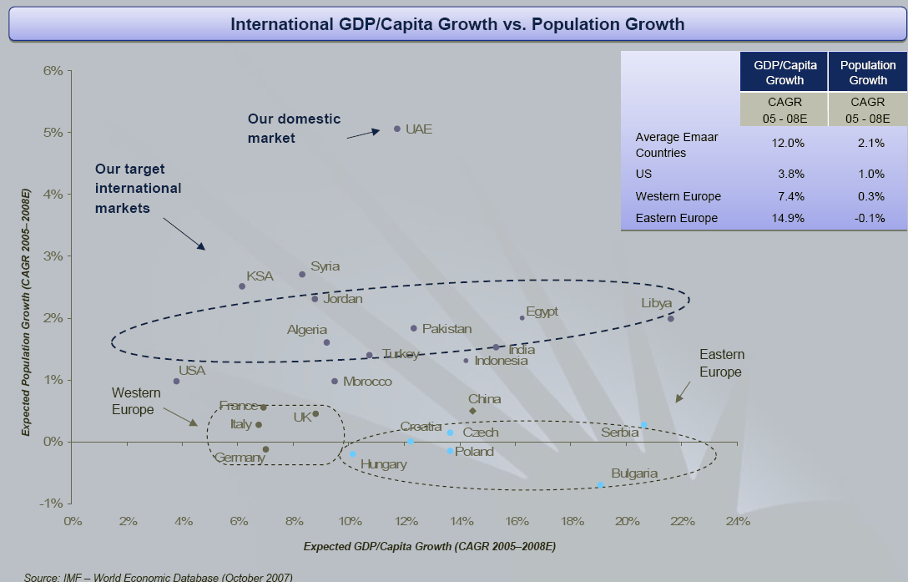
Figure 7
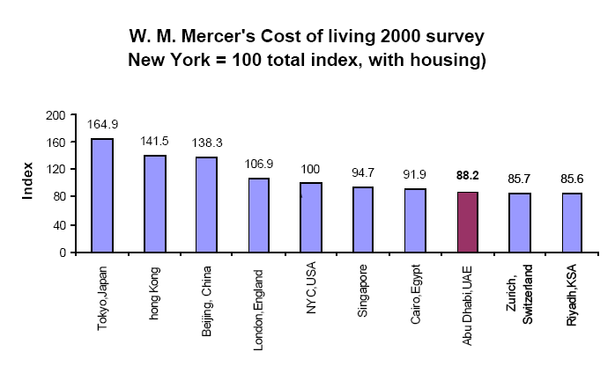
Bibliography
Jones, Rhys. “Viva Dubai?” Middle East 371 (2006) : 46-47.
“Regional Opportunity.” Dubai International Financial Center. 12 November 2007 http://www.difc.ae/about_difc/regional_opportunity/
“United Arab Emirates.” Oxford Economic Country Briefings 14 June 2007
Dubai Internet City- http://www.dubaiinternetcity.com/why_dubai/
Dubai Health Care System- http://www.dhcc.ae/en/Default.aspx?type=1&id=41
Dubai Financial Market- http://www.dfm.co.ae/dfm/Main/Main.htm
Dubai Holding Company- http://www.dubaiholding.com/
Merill Lynch- http://www.ml.com/index.asp?id=7695_15125_17454
Gulf News- http://archive.gulfnews.com/indepth/labour/Emiritisation/10059252.html
ABC News - http://abcnews.go.com/Business/wireStory?id=2941931

